COVID-19 response
Melbourne civil jury trials – guide for the profession and court users

DOCUMENT CONTROL
Details
Document type | Emergency Protocol COVID-19
Division | Common Law Division
Authorised by | Judge Tsalamandris, Head of Common Law Division
Notes

Release history
Version | Date | Author | Summary of changes
1.0 | 1/3/2021 | Judge Tsalamandris,  Head of Common Law Division | Document created
2.0 | 17/3/2021 | Judge Tsalamandris,  Head of Common Law Division | Removal of unnecessary appendices, updated ‘pre-trial matters’ procedures, updated association with tested person guide.

Related documents
Document title | Version
Court Services Victoria’s COVID Safe Plan | N/A
County Court of Victoria Tier 2 COVID Safe Plan | N/A
Appendix 1: Hand washing protocol | N/A
Appendix 2: Safe use of hand sanitiser protocol | N/A
Appendix 3: Safe mask use and disposal protocol | N/A
Appendix 4: Safe glove use and disposal protocol | N/A
Appendix 5: Safe use of face shield protocol | N/A

CONTENTS
1. Background 5
Decision to recommence jury trials 5
2. Guiding principles 6
Occupational health and safety 6
Integrity of the civil jury trial 6
Comfortable compliance 6
Mutual obligations to health and safety 6
3. General Information 7
Juries Victoria measures 7
COVID-19 factsheet for jurors 7
Virtual jury pool 7
Applications for excuse or deferral 7
Jury panel of 23-30 7
Remote empanelment from the jury pool room 7
The trial courtroom 8
The jury room 8
Masks 8
Court-provided disposable masks 10
Face shields 11
Disposable gloves 11
Cleaning 11
Juror daily health screening questions 11
Expedited testing protocol 12
4. Pre-trial matters 13
5. Jury empanelment 14
Remote empanelment process 14
6. The jury trial in court 21
Conduct of the trial 21
Movement of jurors and alerting the tipstaff/jury keeper 25
Jury movement 25
Alerting the tipstaff/jury keeper 26
7. Guidelines if a trial is impacted by COVID-19 27
Association with tested person guide 27
Suspected case guide 28
Positive test guide 34
Expedited testing protocol 36
APPENDIX 1: Hand washing protocol 37
APPENDIX 2: Safe use of hand sanitiser protocol 38
APPENDIX 3: Safe mask use and disposal protocol 39
APPENDIX 4: Safe glove use and disposal protocol 40
APPENDIX 5: Safe use of face shield protocol 41

Background

Decision to recommence jury trials
  - The Supreme Court and the County Court made the precautionary decision to suspend all new jury trials from 16 March 2020.
  - Consistent with the roadmap to the lifting of restrictions announced by the Victorian Government, the court resumed criminal jury trials on 16 November 2020.
  - In consultation with health advisors a COVID-safe process for the conduct of civil jury trials has now been developed to eliminate, as far as is reasonably practicable, risks to the health and safety of jurors, judges, staff, legal practitioners and other court users.
  - This document sets out the modified procedures for the conduct of civil jury trials and provides a suite of guides to assist the profession and court users if a trial is impacted by the coronavirus (COVID-19).
  - It should be noted that criminal jury trials take priority over civil jury trials, and as such, the Court cannot guarantee the availability of juries for civil trials. Parties will be advised when a jury trial may be available, however if the circumstances are such that proceeding as a civil jury trial is no longer possible as the proposed jury panel is needed for a criminal trial, the matter will then ordinarily proceed as a judge alone trial, so as to avoid unnecessary delay.

Guiding principles

Occupational health and safety
  - The measures adopted throughout this process are intended to comply with the Court’s duty under the Occupational Health and Safety Act 2004 (Vic) to ensure, so far as is reasonably practicable, the health and safety of judicial officers, staff, jurors and court users by:
    - eliminating risks to health and safety so far as is reasonably practicable
    - where it is not reasonably practicable to eliminate risks to health and safety, to reduce those risks so far as is reasonably practicable.

Integrity of the civil jury trial
  - The measures adopted throughout this process are also intended to ensure that:
    - the fairness and integrity of a civil jury trial is maintained
    - the parties can properly and fully present their cases
    - the presentation and assessment of evidence is not impaired.

Comfortable compliance
  - Given the nature of jurors as members of the community compelled to attend court to perform a public service, the intent of the Court is to ensure, wherever possible, that comfortable compliance – that is, compliance to a degree that is greater than mere strict compliance – is provided.
  - A key aim for the resumption of jury trials has been to ensure that any concerns for health and safety are clearly addressed, to avoid these issues being an impediment or distraction to the conduct of a jury trial and the administration of justice.
  - To ensure this, the profession, jurors and other court users will be required to comply with court guidance on social distancing, the functional capacity (density quotient) of courtrooms and any other spaces, wearing masks, hand sanitisation, and other hygiene measures where required.

Mutual obligations to health and safety
  - All participants in the jury trial will be apprised of, and where required appropriately reminded of, the mutual obligations of all participants to the health and safety of one another.
  - For example, jurors will be instructed that they have a responsibility to stay at home if they are unwell and not place the health and safety of judicial officers, court staff and other court users at risk.
  - All trial participants, including judges, court staff, jurors, counsel, practitioners, witnesses and any other persons permitted in the courtroom are asked to check the DHHS lists of exposure sites (https://www.dhhs.vic.gov.au/case-locations-and-outbreaks) on a daily basis to determine if they, or anyone they live with, or have contact with, may have been at risk of exposure.

General Information

Juries Victoria measures

COVID-19 factsheet for jurors
  - A COVID-19 fact sheet will be sent to jurors with their Jury summons, advising them of the precautionary measures and guidelines for their attendance. This fact sheet is also available on the County Court, Supreme Court and Juries Victoria websites.
  - The factsheet includes advice that jurors are not to attend the Court, and must call Juries Victoria, if they:
    - feel unwell, or have any symptoms of COVID-19
    - have had any contact with a known case of COVID-19
    - currently work or live with anyone who is in quarantine, in isolation or is awaiting test results for COVID-19.

Virtual jury pool
  - Jurors will be summonsed to a ‘virtual pool’ and advised by Juries Victoria staff over the phone of the date and time on which they are required to physically attend Court.
  - Prior to the summons date, Juries Victoria staff will contact jurors in the pool by email to provide further information and offer the opportunity to answer any questions. Where required, for lengthy matters the email will also provide a notice under section 29 of the Juries Act 2000, seeking a response from jurors as to their availability for the particular length of that matter.

Applications for excuse or deferral
  - In addition to the more commonplace reasons for deferral (such as pre-booked leave, small business ownership, etc.) Juries Victoria will give greater consideration to excusing or deferring persons who may be particularly vulnerable to the consequences of COVID-19, or who, for example, would have difficulty complying with the requirement to wear a mask.

Jury panel of 23-30
  - For most matters, only smaller groups of summonsed jurors, comprising up to 30 people, will physically attend the Court to take part in the empanelment process for County Court trials.
  - For longer County Court matters, up to 30 people may be required to physically attend the Court to take part in the empanelment process.
  - Experience to date shows that, on average, fewer jurors seek to be excused during the empanelment process than normal, likely due to the shorter matters that were listed for the initial resumption phase, and the preliminary work considering requests for excuse or deferral by Juries Victoria.

Remote empanelment from the jury pool room
  - The empanelment process will be conducted using video links between the trial courtroom and the jury pool room.
  - Only smaller groups of summonsed jurors comprising up to 30 people will physically attend the Court to take part in the empanelment process. At all times there will be compliance with the 1.5 metre distancing rule and the four-square metre per person rule.
  - While physically distanced, instructing solicitors may observe the jury panel in the jury pool room during the callover and the taking of excuses.
  - During the striking of the jury, the juror will be required to walk to a particular point in clear view of a camera linked to the trial courtroom and stand unmasked for a period of time.

The trial courtroom
  - Physical distancing will be maintained throughout the trial process.
  - In line with Victorian public health advice, any persons in the trial courtroom will be seated 1.5 metres apart.
  - Jury boxes have been extended to ensure they provide appropriate physical distancing. In the body of the court, and at the bar table, signs or markings will indicate which seats may be used and which may not.
  - All persons present in the trial courtroom (including jurors after the choosing of a foreperson) will be expected to use the same seat throughout the trial.

The jury room
  - The jury room will provide physical distancing for jurors during adjournments and deliberation.
  - Soap and hand sanitiser are available and hand washing guidance has been placed above all sinks accessible to the jury room.
  - Empanelled jurors will receive comprehensive information on the COVID-safe measures for the jury room, including physical distancing, hand sanitisation, use of kitchens and bathrooms and the wearing of masks.

Masks
  - The Court’s requirement for trial participants to wear masks is described by the following three settings:
    - mask-wearing by all trial participants is required (setting 1)
    - mask-wearing by non-speaking participants is required (setting 2)
    - mask-wearing is not required for trial participants (a proposed ‘setting 3’).
  - The appropriate setting will be determined by health advice, and the Court alert judges and staff, and will publish advice for the profession and court users, on an ongoing basis, as to the setting that is currently in effect.
  - The chambers of the presiding judge will also advise parties of the setting prior to the commencement of a trial, and during a trial should the setting change.

Mask-wearing by all trial participants (setting 1)
  - Where health advice requires mask-wearing by all participants, all trial participants (judges, court staff, jurors, counsel, practitioners, witnesses and any other persons permitted in the courtroom) will be required to wear masks – including when speaking – save for in the following limited circumstances:
    - a juror may be required to briefly move their mask to one side, while holding the straps, during the callover and answering ‘present’ or ‘excuse’
    - a juror may be required to remove their mask when addressing the Court from the jury pool room during the provision of any verbal excuse, or when addressing to the Court regarding a written excuse
    - a juror will be required to remove their mask during the striking of the jury, when standing at the walk-up point for the required time
    - an in-person witness will be required to remove their mask when being sworn in and for a short period thereafter – as determined by the judge – for the purposes of identification
    - an in-person witness may be required to remove their mask for short periods – as determined by the presiding judge – to facilitate the assessment of the witness’ credibility, during which period a face shield may be worn (see Appendix 5).
  - Any witness appearing remotely is not required to wear a mask while giving evidence.
  - Court staff will not be required to remove their mask at any time, save for the brief period required for identification to the jury panel during empanelment (if this is the preference of the judge). Court staff will continue to wear a mask immediately thereafter.
  - Courtroom microphones will be set to provide a measure of amplification (not just recording) to reduce the need of any person speaking to project their voice.
  - Counsel and instructing solicitors will be requested to wear a disposable mask provided by the Court (using the Safe mask use and disposal protocol in Appendix 3) to allow for any removal and disposal during the empanelment process when trial participants are asked to identify themselves for the benefit of the jury panel.
  - While masks may be removed pursuant to the exemptions above while in court, court users must continue to wear masks when moving throughout the court facility.
  - During orientation, jurors will be provided information (including an instructional video) on the correct process for changing masks as required throughout the empanelment process and the trial.
  - If a person removes a mask, they must dispose of it in the bin provided and use hand sanitiser before picking up and fitting a new mask.
  - The Court will continue to monitor the circumstances and will seek ongoing health advice to determine if this setting is appropriate.

Mask-wearing by non-speaking participants (setting 2)
  - Where health advice permits speaking participants to remove their masks, masks will be worn by all trial participants, save for in the following circumstances:
    - judicial officers and those speaking or addressing the court, including counsel and witnesses, may remove masks
    - a juror may be required to briefly move their mask to one side, while holding the straps, during the callover and answering ‘present’ or ‘excuse’
    - a juror may be required to remove their mask when addressing the court from the jury pool room during the provision of any verbal excuse, or when addressing to the court regarding a written excuse
    - a juror will be required to remove their mask during the striking of the jury, when standing at the walk-up point for the required time
    - any witness appearing remotely, or in-person is not required to wear a mask while giving evidence (after giving evidence in-person, a witness must use hand sanitiser before selecting and fitting a new mask).
  - As an additional measure of comfort to the jury, counsel will be required to conduct any address to the jury from the end of the bar table furthest from the jury, using their own dedicated lectern. The instructing solicitor may also move position to sit near counsel as they address the jury.
  - Counsel and instructing solicitors should move towards the centre of the bar table (if required) to maintain physical distancing when the opposing counsel is addressing the jury.
  - Those addressing the Court may choose to continue to wear a mask so long as they can be clearly heard and understood, at the discretion of the judge.
  - Any witness appearing remotely is not required to wear a mask while giving evidence.
  - Court staff will not be required to remove their mask at any time, save for the brief period required for identification to the jury panel during empanelment (if this is the preference of the judge). Court staff will continue to wear a mask immediately thereafter.
  - Courtroom microphones will be set to provide a measure of amplification (not just recording) to reduce the need of any person speaking to project their voice.
  - Counsel and instructing solicitors will be requested to wear a disposable mask provided by the Court (using the Safe mask use and disposal protocol in Appendix 3) to allow for any removal and disposal during the empanelment process when trial participants are asked to identify themselves for the benefit of the jury panel.
  - While masks may be removed pursuant to the exemptions above while in court, court users must continue to wear masks when moving throughout the court facility, if required.
  - During orientation, jurors will be provided information (including an instructional video) on the correct process for changing masks as required throughout the empanelment process and the trial.
  - If a person removes a mask, they must dispose of it in the bin provided and use hand sanitiser before picking up and fitting a new mask.
  - The Court will continue to monitor the circumstances and will seek ongoing health advice to determine if this setting is appropriate.

Mask-wearing not required (setting 3)
  - Where health advice permits, all trial participants will not be required to wear a mask.
  - In those circumstances the Court will publish a revised guide detailing the consequential changes to the empanelment process.
  - The Court will also continue to monitor the circumstances and will seek ongoing health advice to determine if this setting is appropriate.

Court-provided disposable masks
  - Disposable masks will be available to all court users and those attending for jury duty and participating in a trial.
  - Jurors arriving at the Court wearing their own mask (for example, a non-disposable mask) will be provided with a disposable mask by Juries Victoria staff, and asked to wear it, in order to facilitate the removing (and safe disposal) of masks throughout the empanelment process. Jurors will be notified of this requirement by Juries Victoria staff in advance of their summons date.
  - Similarly, jurors arriving at the Court throughout a trial will be provided with a disposable mask to allow for disposal and changing of masks, throughout the trial.
  - Disposable masks will be available for jurors:
    - at entrance points before security screening
    - in the jury pool room
    - in the jury room.
  - Disposal bins and hand sanitiser will also be provided next to all masks distribution points to allow for safe mask use in accordance with the Safe mask use and disposal protocol (see Appendix 3).
  - In addition to the requirement that a new mask be worn whenever one is removed, on the advice that masks are to be refreshed every four hours, jurors and all court users will be provided with, and asked to wear, a fresh mask after any mid-sitting break in the sitting (see Appendix 3).
  - Supplies of additional masks and appropriate bins for safe mask disposal will be provided in the jury pool room, trial courtroom and the jury room.

Face shields
  - Where required, the use and disposal of a face shield will be in accordance with the Safe use of face shield protocol (see Appendix 5).
  - A number of assembled and sanitised single-use face masks will be available in a box near each witness box, alongside a disposal bin. The witness will be asked to use hand sanitiser before picking up and fitting a face shield. The witness can also place the face shield directly into the disposal bin upon completion of evidence to avoid any staff handling the shields.
  - A supply of masks will also be available for the witness to put on a fresh mask (after sanitising their hands) upon removal of the face shield.

Disposable gloves
  - Disposable gloves will be available to judges, court staff, legal representatives and jurors participating in a trial. The gloves will be available:
    - on the judge’s bench (for the judge)
    - on the judicial staff bench (for judicial staff and jurors)
    - on the bar table (for legal representatives)
    - in the jury room (for jurors).
  - Hand sanitiser will also be provided next to gloves to allow for safe glove use and disposal in accordance with the Safe glove use and disposal protocol (See Appendix 4).

Cleaning
  - The Court has established an additional cleaning regime for the jury pool room, jury room, trial courtroom, deliberation area and jury bathroom with a focus on high touch points in areas used by multiple people. For example, high touch points in the witness box will be cleaned between witnesses.

Juror daily health screening questions
  - Upon entry to the Court building each day, jurors will be asked by a court security officer the following questions:
    - do you feel unwell, or have any symptoms of COVID-19?
    - have you had any contact with a known case of COVID-19?
    - do you currently work or live with anyone who is in quarantine, in isolation, or is awaiting test results for COVID-19?

Expedited testing protocol
  - The Court and Court Services Victoria have developed the Expedited testing protocol which will facilitate the testing of any trial participant for COVID-19, and the receipt of results within 24 hours.
  - It is anticipated that a trial would only require a maximum adjournment of one day in order to facilitate the testing and receipt of the results.
  - Jurors will be advised during the Juries Victoria orientation and by the Judge in their initial instructions, that they will be asked to consent to a testing protocol if selected as a juror, although completing the consent forms (and ultimately any testing) is voluntary.
  - Parties will be provided in advance of the trial with consent forms to complete (if they wish) and send to the chambers of the presiding judge for safe retention, in the event that expedited testing of counsel, instructing solicitors or witnesses is required.
  - Similarly, judges and staff may complete in advance the consent forms (if they wish) to facilitate the arrangement of expedited testing if this is required.
  - A summary of the Court Services Victoria’s Expedited testing protocol is described on page 36.

Pre-trial matters
  - It is suggested that, in addition to the usual matters, counsel should assist the Court by addressing the following matters, if not already raised with the judge’s chambers:
    - confirming details of all court attendees
    - confirming whether parties propose to have witnesses give evidence in person or remotely
    - whether an interpreter or support person is required for the plaintiff or any other witness
    - whether a view is required and what assessment has been made of the capacity to conduct a view with appropriate social distancing/density requirements

Jury empanelment

Remote empanelment process
  - Jury empanelment will be conducted remotely via videolink between the jury pool room and the trial courtroom (as described above).
  - Instructing solicitors will be able to view the panel by attending the jury pool room (escorted by a Juries Victoria officer) during the callover and the taking of excuses. The instructing solicitors will then return to the trial courtroom for the remainder of the empanelment.
  - Remote empanelment will be assisted by court staff in the following manner:
Judicial staff model | Trial Courtroom | Jury Pool Room
Associate and Tipstaff | Associate and Tipstaff 1 | Tipstaff 2
Two Associates | Associate and Second associate | Tipstaff 2

  - The table below outlines modified procedures for remote jury empanelment.
Event | Procedure
Panel arrives at court | As members of the panel arrive at Court, and register with Juries Victoria staff they will be directed to answer the following health screening questions:  - do you feel unwell, or have any symptoms of COVID-19?  - have you had any contact with a known case of COVID-19?  - do you currently work or live with anyone who is in quarantine, in isolation, or is awaiting test results for COVID-19?  If the panel members answers ‘no’ to each question, they will be directed by Juries Victoria staff to sit in their assigned seat in the jury pool room.  If the panel member answers ‘yes’ to any of the questions, they will not enter the pool room, and will be directed to isolate and/or seek medical assistance as required.  If a juror arrives wearing their own mask, they will be provided with a disposable mask that is required to be worn (and replaced) throughout the empanelment process.
Jury panel orientation | Second associate/Tipstaff 1 will be assigned to the trial courtroom and tipstaff 2 will be assigned to the jury pool room.  Juries Victoria staff conduct orientation in the jury pool room.  Juries Victoria staff and jurors will wear masks during the orientation process.  The jurors’ panel number will be placed on their seat.  Individual chairs in the jury pool room are numbered in sequential order.  If required, list of witnesses/parties placed on jurors’ seats.  Each juror will be required to wear a mask and replace with a fresh mask each time a mask is removed. Jurors will be directed when this occurs, including the direction to dispose of the used mask and use the hand sanitiser before picking up and fitting a new mask. The disposal bin, hand sanitiser and new masks will be provided.
Tipstaff directions | After orientation by Juries Victoria staff, tipstaff 2 will give an overview of the process to the panel describing the:  - callover  - taking of excuses – and the location to move to for excuses (and provision of written excuses if required)  - striking of the jury and process of empanelment - and the location to move to for empanelment  - dedicated location in the jury lounge area that they will be moved to if selected.
Judge opens court | Matter is called on in trial courtroom in the absence of the jury.  Judge, second associate/tipstaff 1, counsel and instructing solicitors in the trial courtroom.  Counsel and instructing solicitors must not use the area marked ‘Associate Use Only’ in the centre of the bar table.  Tipstaff 2 remains in the jury pool room.  Second associate/tipstaff 1 advises Juries Victoria staff in the jury pool room that the judge is ready to empanel.
Authorisation and address to jury panel | Judge, associate, second associate/tipstaff 1, counsel and instructing solicitors, remain in the trial courtroom.  Second associate/tipstaff 1 establishes videolink between the jury pool room and the trial courtroom.  Once all persons are in place tipstaff 2 advise second associate/tipstaff 1.  Second associate/tipstaff 1 advise judge/associate court is ready.  Matter is called on for a second time in the presence of the jury panel, who are seated in the jury pool room.  Judge declares the jury pool room an extension of the Court, and associate an authorised officer for the purposes of calling the panel and selecting the jury.  Juries Victoria staff member hands juror number cards to the associate.  Cards should be handled using gloves, in accordance with the Safe glove use and disposal protocol (Appendix 4). Alternatively, associate must use hand sanitiser before and after handling jury number cards.  Counsel asks the judge for leave for instructing solicitors to attend the jury pool room to view the callover and taking of excuses.
Instructing solicitors move from trial courtroom to jury pool room | Juries Victoria officer escorts the instructing solicitors to the jury pool room.  Instructing solicitors travel in public area from trial courtroom to jury pool room, complying with physical distancing and maximum lift occupancy requirements.  Upon arrival in jury pool room, instructing solicitors may then observe the panel from either side of the jury pool room (physically distanced from panel members, Juries Victoria staff and County Court staff), standing on the assigned floor decals.  Court staff advise trial courtroom that instructing solicitors are in place.
Judge gives instruction to jury panel | Judge advises jury panel that, when their number is called, potential jurors should state ‘Present’ or if seeking to be excused, state ‘Excuse’ during the callover.  Judge directs the associate to call through the jury panel.
Jury panel callover | Videolink is continued.  Associate reminds the jury pool that the numbers that will be called out are their panel numbers, which have been highlighted.  Associate instructs the jury pool that when their panel number is called, they should stand at their seat and answer with ‘Present’ or ‘Excuse’.  At the discretion of the judge, jurors may be instructed to briefly remove their mask or hold it to one side during this process.  Associate calls over the panel.  Associate will separate cards of jury panel members who seek to be excused for judge.  Associate queries if there are any jurors present whose Panel number has not been called.  Associate advises judge that all jurors are present.
Excuses – process 1 (written excuses scanned) | Videolink is continued.  Where a written excuse is to be provided, the camera view on the jury pool room will be widened to a pre-set to allow for the edge of the table to be seen (so the writing process is in view of the trial courtroom).  The juror is asked to use hand sanitiser before selecting a new pen and writing their excuse using the paper on the table at the walk-up point.  When the excuse has been written, the juror disposes of the pen in the ‘Used pens’ box provided, folds the excuse so it cannot be read, and hands it to a tipstaff.  The juror is asked to remain standing at the walk-up point.  Tipstaff 2 uses gloves to receive folded, written excuse and unfolds it face-down on the scanner flatbed, so as not see the excuse.  The preset email for the judge is used to scan and send the excuse directly to the judge’s email.  Once confirmation of receipt of the emailed excuse, the written excuse is then removed from the scanner, and in view of the juror is torn up and placed into a bin.  The scanner should be sanitised after each use, using the approved cleaning wipes provided, placed next to the scanner.  The judge will then determine the excuse and the juror will be asked to use hand sanitiser before fitting a new mask and returning to their assigned seat.  If excused, the associate excludes the potential juror’s number from the ballot for empanelment.
Excuses – process 2 (written excuses delivered to courtroom) | Videolink is continued.  Where a written excuse is to be provided, the camera view on the jury pool room will be widened to a pre-set to allow for the edge of the table to be seen (so the writing process is in view of the trial courtroom).  The juror is asked to use hand sanitiser before selecting a new pen and writing their excuse using the paper on the table at the walk-up point.  When the excuse has been written, the juror disposes of the pen in the ‘Used pens’ box provided, folds the excuse so it cannot be read, and writes their juror number on the outside of the paper, and hands it to tipstaff 2.  If there is more than one juror seeking to be excused, the juror must then use hand sanitiser before fitting a new mask and returning to their assigned seat.  This process is then repeated for all other jurors wishing to provide, or asked to provide, their excuse in writing.  Written excuses are then conveyed as a batch to the trial courtroom by Tipstaff 2 wearing disposable gloves and handed directly to the judge.  The judge may wear gloves or use hand sanitiser (or both) when handling the written excuses.  The judge will read each of the written excuses and may determine each of those excuses and advise the jury members without need for the jurors to come up to the walk-up point.  However, if the judge needs to question any juror on their written excuse, the juror will be called individually to come up to the walk-up point and must remove their mask and dispose of it in the bin provided. In those circumstances, once each excuse is determined, the juror will again be asked to use hand sanitiser before fitting a new mask and returning to their assigned seat.  If excused, the associate excludes the potential juror’s number from the ballot for empanelment.
Instructing solicitors move from jury pool room to trial courtroom | Instructing solicitors travel in public area from jury pool room to trial courtroom, complying with physical distancing and maximum lift occupancy requirements.
Strike jury | Videolink is continued.  Judge directs associate to strike a jury.  Associate moves to the centre of the bar table, in view of the bar-wide camera.  Associate advises the jury panel that, as their number is called, they should stand and move to the walk-up location in front of the camera and remove their mask.  NOTE  Court allows for 30 seconds for a challenge or request to stand aside once juror reaches the walk-up location and removes their mask.  A clock displayed in courtroom shows a countdown of time in which to challenge/request to stand aside.  When juror’s number is called, the juror walks to the walk-up location in the jury pool room.  When the juror reaches the walk-up location and removes their mask, second associate/tipstaff 1 commences the countdown clock in the courtroom.  Second associate/tipstaff 1 then resets the countdown clock prior to the ballot of the next juror.  Associate will write down the number on the list of 10 jurors  Once 10 jurors have been called out, the videolink to the jury pool room will be paused to allow for counsel to confidentially discuss the striking out process  Associate then hands the list of jurors to the plaintiff instructing solicitor to strike out 2 numbers  Associate will move back to the judicial staff bench for a period to allow for confidential discussion, before returning to receive the list of jurors.  Associate then hands the list of jurors to the defendant instructing solicitor to strike out 2 numbers  Associate will again move back to the judicial staff bench for a period to allow for confidential discussion. before returning to receive the list of jurors
6 jurors empanelled | Videolink is de-activated/un-paused.  Once 6 jurors are selected, the judge asks remaining jury panel members to remain seated in their assigned seats in the jury pool room until discharged.  NOTE  The judge should adjourn the Court for a short period at this stage, to allow for the movement of the jurors and a bathroom break, and to allow for movement to the trial courtroom from the empanelment courtroom (where the trial courtroom is not an upgraded court).  Timing of the movement of jurors suggest that approximately 15 minutes will be required to move the jury of 6 from the jury pool room to the trial courtroom, abiding by the maximum of 2 persons per lift journey.  Judge adjourn the matter in the empanelment courtroom.
COVID testing consent forms | During the adjournment, prior to moving to the trial courtroom, Juries Victoria staff will distribute consent forms consistent with the Expedited Testing protocol on page 36 using individual clipboards and individual pens.  Juries Victoria staff will use gloves to both distribute and collect the clipboards and pens.  Sanitising of the clipboards will be coordinated by Juries Victoria staff, before any re-use.
Jurors move to jury room | Tipstaff 2 escorts the jurors to the jury room and provides advice about the order of seating for entry into the trial courtroom.  Second associate/tipstaff 1 in the trial courtroom to confirm court is ready to proceed then moves jurors into the jury box.  Videolink to jury pool room is switched off.
Instructing solicitors may need to leave trial courtroom | Instructing solicitors are only permitted in the trial courtroom where there are only two parties who are legally represented. In matters with three parties legally represented, only two legal representatives per party are permitted in the trial courtroom. In such circumstances, if a party has two counsel appearing, the instructing solicitor for such a party must leave the courtroom and instruct remotely.
Swear in jury | Videolink is continued.  Empanelled jury members arrive and are assembled in the jury room, prior to entering trial courtroom.  Second associate/tipstaves 1 and 2 coordinate the entry of the jury into the trial courtroom, noting the preference to seat a taller person (where possible) in the front row seat that is closest to the judicial bench (in trial courtrooms other than 3.3).  Associate/jury keeper tipstaff instructs/escorts empanelled jury members to take a seat in the extended jury box. Associate assists with directing jury members into the jury box.  Judge advises jurors that they may swear an oath or make a promise, or take an affirmation (with explanation as to the difference) and that, as a religious text will not be provided, this is not needed for an oath to have full force and effect.  If giving an oath, religious texts will not be used.  - If a person wishing to swear an oath declines to do so without a religious text, they will be required by the judge to affirm.  Judge instructs the associate to swear in the jury.  Jurors sworn in.
Court resumes | Videolink is continued.  Judge discharges the remainder of the jury panel using the videolink.  NOTE  Remaining jury panel members in the jury pool room exit the court building using the Little Lonsdale Street exit.  Any list of witnesses/parties remaining are disposed of by Juries Victoria staff.  Jury pool room is cleaned for the next empanelment.  Juries Victoria will communicate (by email) with discharged panel members to ask that Juries Victoria be notified in the following 14 days if the panel member tests positive for COVID-19.  Videolink is terminated.

The jury trial in court

Conduct of the trial
  - The following table outlines modified procedures to support the health and safety of judges, staff, jurors and court users from commencement of the trial to verdict.
  - The procedures are described on the basis that, after the empanelment process is completed, and the judge’s initial directions given, the judge should ordinarily adjourn the jury for that day.
  - On the next day of the trial, the jurors will choose their foreperson prior to entering the trial courtroom for that day – thereby allowing any necessary re-seating to take place in a safe manner (given the overnight cleaning that will have taken place).
Event | Procedure
Initial directions to jury | Judge provides directions to sworn jurors on the usual matters in addition to the measures for COVID-19 safety.  Judges who would ordinarily ask the jury to choose a foreperson during the first adjournment should instead ask the jury to choose before recommencing the following day. This will allow the jury box to be cleaned between the necessary re-seating to allow for the foreperson to be seated in the appropriate location.  Judge directs tipstaff 1 to adjourn the court.
First adjournment after jury sworn in | Second associate/tipstaff 1 escorts jury to the jury room.  Jurors familiarise themselves with jury room.  NOTE  Signs outside the jury room state the room capacity based on the 2 square metres per person rule. The room will have 6 jurors plus a staff member (when jury not deliberating).  Stickers or labels identify which seats can be used by which jurors – 1.5 metres apart. Additional furniture will be removed.  Signs inside jury room with information on distancing and hygiene, sanitiser availability, cough/sneeze etiquette.  Second associate/tipstaff 1 provides the initial information briefing to jurors  Second associate/tipstaff 1 escorts jury from jury room to trial courtroom.  Prior to closing the Court for the day, the judge reminds jury to keep their assigned seats throughout the entire trial (if a foreperson has been chosen) and requests jurors to observe physical distancing when arriving at and entering the Court each day.
Re-seating after jury choose foreperson | As described above, the judge should ask the jurors to choose a foreperson in such a way as to allow for the overnight cleaning of a jury box (for example, that the jury choose the foreperson the following day, prior to the commencement of the trial for that day).  Prior to entering the courtroom, the tipstaff will then direct the foreperson to be seated at the seat closest to the microphone, and exchange seats with the person who had been sitting in that seat. (Note the preference to seat a taller person, where possible, in the front row seat that is closest to the judicial bench for trial courtrooms other than 3.3).  All other jurors will be seated where they had previously sat.  Jurors will then be instructed to maintain the same seating arrangement for the rest of the trial.  The second associate/tipstaff will create a seating map for the jurors for both trial courtroom and seating in the jury room (template to be provided).
When jurors arrive at court | Prior to entering the Court each day, a court security officer at the Little Lonsdale Street jury entry door will direct jurors to answer the following health screening questions:  - do you feel unwell, or have any symptoms of COVID-19?  - have you had any contact with a known case of COVID-19?  - do you currently work or live with anyone who is in quarantine, in isolation, or is awaiting test results for COVID-19?  NOTE  For efficiency in the entry of empanelled jurors, the questions will be displayed on a prominent poster-sized sign. However, the Juries Victoria staff member will still ask the attending juror to answer the questions.  If any juror answers yes to a screening question, they will be isolated and directed by Juries Victoria staff member to a room, pending a decision by the judge in accordance with the Guidelines if a trial is impacted by COVID-19 on page 27.  Any area occupied by a juror answering ‘yes’ to any question will then be cleaned.  If a juror answers no to screening questions, the juror travels to the jury room using the assigned jury lift (maximum 2 persons per lift journey).  After the jury is assembled in jury room, the tipstaff escorts the jury to the trial courtroom, reminding them again to take their allocated seat.
Opening and closing addresses to the jury | - As an additional measure of comfort to the jury, counsel will be required to conduct any address to the jury from the end of the bar table furthest from the jury, using their own dedicated lectern.  - The court will provide each counsel with a lectern.  - Counsel and instructing solicitors should move towards the centre of the bar table (if required) to maintain physical distancing when the opposing counsel is addressing the jury.
Exhibits and other evidence | Parties will be advised that exhibits and other evidence that the jury is required to touch are to be minimised.  Where there are physical exhibits, staff, lawyers, witnesses and jurors are provided with hand sanitiser and gloves to handle in accordance with the Safe glove use and disposal protocol (see Appendix 4).  Each juror is to be provided with individual copies of documentary evidence, rather than shared folders, to minimise contact between jurors.  Parties will be advised to have sufficient copies for all participants as necessary including all jurors.  Where necessary, the associate or tipstaff will make individual copies for jurors, ensuring that gloves are worn in accordance with the Safe glove use and disposal protocol (see Appendix 4).
Witnesses called to give evidence | Generally, all witnesses will give evidence remotely unless this is not appropriate.  In particular, vulnerable witnesses (due to age or health condition) are to give evidence remotely.  Witnesses in remote witness rooms are not required to wear a mask or a face shield.  Under setting 1, where all trial participants must wear a mask, an in-person witness:  - will be required to remove their mask when being sworn in and for a short period thereafter – as determined by the presiding judge – for the purposes of identification  - may be required to remove their mask for short periods – as determined by the presiding judge – for the purposes of an assessment of credibility of evidence, during which period a face shield may be worn (see Appendix 5);  - a box of face shields will be available in each trial courtroom. The tipstaff may direct the witness to use hand sanitiser before picking up and fitting a face shield. The witness may dispose of a face shield directly into a bin, to avoid any handling by court staff.  Under setting 2, where those speaking are not required to wear a mask, an  in-person witness is not required to wear a mask when giving evidence.  If giving an oath, religious texts will not be used.  If a person wishing to swear an oath declines to do so without a religious text, they will be required by the judge to affirm.  Second associate/tipstaff to advise the Court’s Facilities team when an in-person witness concludes giving evidence.  Adjournment will be required if consecutive witnesses are to appear in-person.  Witness box cleaned by the Facilities team and disinfected between in-person witnesses, allowing 10 minutes to be effective.
Lunch break | Second associate/tipstaff/jury keeper escorts jurors back to the jury room.  Second associate/tipstaff/jury keeper to distribute and collect lunch order forms.  Jurors will be provided with individually wrapped lunches, so they don’t increase their exposure by going to cafes and restaurants etc.  Court staff will deliver lunches to the jury room.  Disposable cutlery/cups provided.  Jurors are not confined at lunchtime – they may go for a walk, but they are reminded by the judge before the court is adjourned to limit their exposure.
Jury retires for the day | Before adjourning for the day, jurors will be reminded by the judge to limit their risks of exposure outside of the Court.  Second associate/tipstaff/jury keeper escorts jurors back to jury room to collect their belongings, maintaining physical distancing.  Associate or tipstaff keeps a record in the Pink book of who was in the trial courtroom and jury room each day (jurors identified by number).  Trial courtroom and jury room are cleaned overnight.
Offsite view | Location assessed in advance for capacity to distance by judge’s staff in coordination with the Chief Judge’s chambers.  If location incompatible with distancing explore alternatives – for example, using video/models.  Second associate/tipstaff delivers standard view brief in addition to safety brief (using script to be provided tailored for the particular case and location).  Travel to location and back on large bus or multiple buses (additional staff required where multiple vehicles).  Jurors and staff distanced on bus and asked to return to same seat.  Location of view cleared of other people by the associate and second associate/tipstaff.  Jurors and person conducting view instructed by tipstaff on keeping distance while view conducted.  Masks to be used throughout, disposal bins, hand sanitiser and replacement masks will be made available on buses and on site.
Jury in deliberation | Only the jury is present in the jury room at this stage.  Jury keeper will remain in the trial courtroom while the jury is in deliberation.  Jurors will be instructed to put away materials at the end of each day, and that they are not to speak to any cleaners they may encounter.
Jury questions | Jurors notify jury keeper seated outside the jury room by ringing the buzzer when they have a question.  The usual process for the receiving of written questions is followed, however the jury keeper should use gloves to receive any written questions from the jury.  The associate and judge should also use gloves if receiving any written questions from the jury.  The Safe glove use and disposal protocol (see Appendix 4) should be followed by all persons involved in the handling of written questions.  When required, jury keeper escorts jurors to the trial courtroom (reminding jurors to take their same seats) and judge provides answer to their question or provides direction.
Verdict | Jury notifies jury keeper by ringing the buzzer provided and advising that they have reached a verdict.  Court is reconvened and the jury brought into the trial courtroom.  Once the verdict is given, the tipstaff contacts a Juries Victoria staff member to advise that the jury is about to be discharged.  Jury keeper then takes the jury to the jury room.  Jury keeper gives standard discharge brief, including reminders about  - personal items  - exhibits  - notes and writing material  Jurors use the juror exit from the Little Lonsdale Street, maintaining social distancing.

Movement of jurors and alerting the tipstaff/jury keeper

Jury movement

Start time
  - Following commencement of a trial, jurors arriving each day will proceed through the dedicated jury entry on Little Lonsdale Street and, having answered ‘No’ to the screening questions, travel by lift (socially distanced) to their jury room for the appropriate start time.
  - Consistent with usual practice, apart from cleaners, other persons (such as contractors) will be prohibited from using the jury lifts unless with strict prior arrangement and coordination with the Court.

Adjournments
  - Where legal argument or another reason means an adjournment for a period is required, the tipstaff will escort the jurors from the trial courtroom to the jury room at the conclusion of the adjournment.

Finish time
  - At the finish time for the day, the tipstaff will escort the jurors from the trial courtroom to the jury room.
  - The jurors will then use the lift assigned to the jury room to exit the building through the juror exit on Little Lonsdale Street.

Alerting the tipstaff/jury keeper
  - The jury will use the normal buzzer in the jury room to alert the tipstaff or jury keeper.

Guidelines if a trial is impacted by COVID-19
  - This set of guides outlines the actions to be taken in the event a trial is impacted by one of the following:
    - a trial participant being associated with a tested person who is a contact of a known positive case
    - a suspected case of COVID-19
    - a confirmed case of COVID-19.

Association with tested person guide
  - If a person is associated with a person being tested, the person does not need to isolate (Scenario A), unless the person being tested is a contact of a known positive case (Scenario B).
  - Scenario A
Tested Person | → | Person Associated with Tested Person  (Isolation not required)

  - Scenario B
Positive Case | → | Tested Person | → | Person Associated with Tested Person  (Isolation pending results required)

  - The following table outlines the process to be actioned for Scenario B, if a trial participant advises that they are associated with a person (‘Tested Person’) wand the Tested person is a contact of a known positive case.
  - A person will be an ‘Associated Person’ if they meet one of the following criteria:
    - had face-to-face contact with the Tested Person
    - shared a closed space with the Tested Person (this would include working in close proximity with the Tested Person)
    - live in a household with the Tested Person.
Scenario | Actions
Judge, staff member, juror, counsel, practitioner or witness reports they are associated with a Tested Person (where the result is not yet known) | Notification  Juror notifies Juries Victoria by phone (if at home) or notifies tipstaff or Juries Victoria staff (if at the Court) that they are an Associated Person.  Judge, staff member, counsel, practitioner or witness reports they are Associated Person.  The Associated Person should not attend the court facility.  If already at the Court, the judge, staff member, counsel, practitioner or witness should leave the court facility if they become aware that they are an Associated Person. Accident Incident Report to be completed using the Accident Incident Reporting System (AIRs).  If already at the Court, the juror should be isolated in a room by Juries Victoria staff (or tipstaff) until they receive further instruction from the judge. Accident Incident Report to be completed using the Accident Incident Reporting System (AIRs).  Judge should notify the Chief Judge and head of division.  Head of division will notify associate/s and tipstaff, if not already notified.  Directions to jurors and parties  Judge to determine whether the trial should be adjourned sine die and ask the Associated Person to remain in isolation until test results of the Tested Person received or whether to discharge the jury.  Associate to follow usual processes and make appropriate notifications to Juries Victoria and the relevant Registry staff in accordance with the judge’s decision.  Adjournment  If the trial is adjourned and if the Associated Person’s test results return negative, the associate is to liaise with the parties and the relevant Registry to staff arrange for the trial to be relisted if directed to do so by the judge.  Associate to notify the parties and Juries Victoria staff of the resumption date once confirmed.  Juries Victoria staff to notify jurors of the resumption date.  If the trial is adjourned and if test results return positive, it is likely that the Associated Person will need to be tested, and the ‘Suspected case guide’ (see ‘Any person tested for COVID-19 during the trial’ in the ‘Suspected Case Guide’).

Suspected case guide
  - The following table outlines the process to be actioned if the Court receives notification that a person is experiencing symptoms associated with COVID-19.
Scenario | Actions
Juror reports being symptomatic | Notification  Jurors are instructed by the judge that they should not attend the court facility if they are experiencing symptoms.  Juror symptomatic at home  Jurors instructed that they should contact Juries Victoria as early as possible (on the number provided) to advise if they will not be attending and provide reasons.  If Juries Victoria staff receive notification that a juror will not be attending due to being symptomatic, Juries Victoria staff to advise the Chief Judge and the judge.  Juror symptomatic at screening  If any juror reports experiencing symptoms at the entry screening questions by a Juries Victoria staff member, Juries Victoria staff to isolate the juror, and advise the Chief Judge and the judge. Accident Incident Report to be completed using the Accident Incident Reporting System (AIRs).  Juror symptomatic while at court  If juror reports experiencing symptoms during the trial, the tipstaff removes the juror from the jury room (or other location) and escorts them to an empty meeting room on the same floor of the court facility (maintaining appropriate distancing), and advises the juror to remain in the room until they receive further instruction. Accident Incident Report to be completed using the Accident Incident Reporting System (AIRs).  Tipstaff notifies judge and associate (where relevant) that a juror has reported being symptomatic.  Judge alerts the Chief Judge and head of division that their trial has been disrupted due to a juror being symptomatic.  Associate notifies Juries Victoria staff that a juror has reported being symptomatic and advises of the juror’s location.  Testing  Juries Victoria arrange for a referral for testing (using the Expedited testing protocol on page 36).  If juror did not attend the court and is at home, Juries Victoria staff will advise the juror that they will be receiving a call from Court Services Victoria to facilitate the testing process.  If the juror is at the court facility, Juries Victoria staff to attend to the juror’s location (maintaining appropriate distancing) and advise that a qualified person will be in touch via telephone to facilitate testing (see Expedited testing protocol on page 36).  Juries Victoria staff to advise the Facilities team of the meeting room in which the juror is/was located for the purpose of cleaning once the juror departs.  Testing of the juror will be conducted in accordance with the Expedited testing protocol on page 36.  Directions to jurors and parties  Judge to determine whether the trial should be adjourned sine die until test results are received or whether to discharge the jury.  The Court will reconvene in the absence of the jury, and the judge will advise the parties of their intended course of action and invite submissions.  Decision regarding the future conduct of the trial will be announced in the presence of the jury and direction given.  Associate to follow usual processes and make appropriate notifications to Juries Victoria and Criminal/Civil Listings staff in accordance with the judge’s decision  If the trial is to continue, the judge is to advise remaining jurors and parties of additional cleaning arrangements.  Adjournment  If the trial is adjourned and if test results return negative, the associate to arrange for the trial to be relisted when directed to do so by the judge.  Associate to notify the parties and Juries Victoria staff of the resumption date  Juries Victoria will notify jurors of the resumption date.  If the trial is adjourned and if test results return positive, see Positive test guide on page 34.  Cleaning  If the person being tested has occupied any part of the building after an overnight cleaning, the trial courtroom, jury room and all spaces occupied by the symptomatic person will be cleaned.
Counsel reports being symptomatic during trial | Notification  Counsel must not attend the court facility if they are experiencing symptoms and should report experiencing symptoms at any stage during the trial.  Counsel must contact the judge’s chambers as soon as possible (by email or on a number provided) to advise if they are symptomatic and will not be attending. Accident Incident Report to be completed using the Accident Incident Reporting System (AIRs).  Associate to advise the judge that counsel has reported being symptomatic and will not be attending.  Judge notifies the Chief Judge and head of division that their trial has been disrupted due to counsel being symptomatic.  Testing  Associate for the judge contacts Court Services Victoria in compliance with the Expedited testing protocol on page 36 to seek referral for urgent testing of counsel.  Head of division to advise judge that notification has been received.  Directions to jurors and parties  Judge to adjourn sine die until test results received.  The Court to reconvene in the absence of the jury to discuss the future conduct of the trial with impacted counsel appearing remotely via telephone or videolink, where health status allows.  After hearing from counsel, decision regarding the future conduct of the trial will be announced in the presence of the jury and appropriate directions provided.  Associate to follow usual processes and make appropriate notifications to Juries Victoria and the relevant Registry staff in accordance with the judge’s decision.  The judge to advise jurors and parties of additional cleaning arrangements.  Adjournment  If test results return negative, the associate is to arrange for the trial to be relisted.  Associate to notify the parties and Juries Victoria staff of the resumption date and time.  Juries Victoria will notify jurors of the resumption date.  If test results return positive, see Positive test guide on page 34.  Cleaning  If the person being tested has occupied any part of the building after an overnight cleaning, the trial courtroom and all spaces occupied by the symptomatic person will be cleaned.
Instructing solicitor reports being symptomatic during a trial | Notification  Solicitors must not attend the court facility if they are experiencing symptoms.  If their instructing solicitor reports being symptomatic, counsel must advise the associate and opposing counsel via telephone or email; or alternatively, advise the judge when court resumes in the absence of the jury. Accident Incident Report to be completed using the Accident Incident Reporting System (AIRs).  Testing  Judge to enquire with counsel whether the instructing solicitor intends to undergo testing for COVID-19.  Judge to request that counsel advise the Court when the result from any testing is received.  If test results return positive, see Positive test guide on page 34.  Directions to jurors and parties  Judge to determine whether the trial can continue, should be adjourned sine die until test results received or whether to discharge the jury.  Judge to consider whether it is appropriate to advise the jury that an instructing solicitor has reported being symptomatic and is undergoing testing.  Adjournment  If test results return negative, the associate is to arrange for the trial to be relisted.  Associate to notify the parties and Juries Victoria staff of the resumption date and time.  Juries Victoria will notify jurors of the resumption date.  Cleaning  If the person being tested has occupied any part of the building after an overnight cleaning, the trial courtroom and all spaces occupied by the symptomatic person will be cleaned.
Witness reports being symptomatic during trial | Notification  Counsel are directed by the judge to advise witnesses who are scheduled to give evidence that they are not to attend the court facility if they are experiencing symptoms.  Counsel are directed to notify the associate and opposing counsel via telephone or email as soon as they are aware that their witness will be unable to attend to give evidence, as scheduled; or alternatively, advise the judge when court resumes in the absence of the jury. Accident Incident Report to be completed using the Accident Incident Reporting System (AIRs).  If a witness has been sworn in, and their evidence carries over into a second day, before excusing the witness, the judge should remind the witness that they are not to attend the court facility if they begin to experience symptoms overnight.  Witness directed to notify relevant counsel if they are unable to attend court to continue giving evidence due to becoming symptomatic overnight.  Counsel are directed to notify the associate and opposing counsel via telephone or email as soon as they are aware that a witness will be unable to attend to give evidence, as scheduled; or alternatively, advise the judge when court resumes in the absence of the jury. Accident Incident Report to be completed using the Accident Incident Reporting System (AIRs).  Testing  If the witness has attended the court facility and commenced giving evidence, judge to request the witness undergo testing for COVID-19.  Judge (or delegate) will provide information to the witness regarding expedited testing and locations (see Expedited testing protocol on page 36).  Judge directs the witness to advise relevant counsel when the test has been performed, and to provide the results once received.  Counsel directed by the judge to advise the associate by telephone or email once notification received from the witness that the test has been performed, and to provide the results once received.  If test results return positive, see Positive test guide on page 34.  Directions to jurors and parties  If the health status of the witness allows, judge to consider whether appropriate in the circumstances to have the witness give (or continue giving) evidence via videolink.  Judge to consider whether it is appropriate to advise the jury that Witness has reported being symptomatic and is undergoing testing.  If the witness has already attended in person and commenced giving evidence, judge to consider whether trial should be adjourned sine die until test results are received or whether to discharge the jury.  Cleaning  If the person being tested has occupied any part of the building after an overnight cleaning, the trial courtroom and all spaces occupied by the symptomatic person will be cleaned.
Any person tested for COVID-19 during the trial | Notification  If any of the trial participants identified above are tested for COVID-19, they will be directed to self-isolate until they receive the results, and are therefore unable to attend the court facility, all appropriate notifications, testing and directions as per the above guidelines are to be applied, with any necessary modifications. Accident Incident Report to be completed using the Accident Incident Reporting System (AIRs).
Any person directed by DHHS to self-isolate during the trial | Notification  If any of the trial participants identified above are determined by Department of Health and Human Safety (DHHS) to be a close contact of a person diagnosed with COVID-19, are directed to self-isolate for a period of 14 days, and are therefore unable to attend the court facility, all appropriate notifications, testing and directions as per the above guidelines are to be applied, with any necessary modifications. Accident Incident Report to be completed using the Accident Incident Reporting System (AIRs).

Positive test guide
  - The following table outlines the process to be actioned if the court receives notification that a person has subsequently returned a positive test for COVID-19 during a trial.
Scenario | Actions
Juror diagnosed with COVID-19 during the trial (while trial is adjourned waiting test results) | Notifications  Juries Victoria staff to notify the presiding judge, Chief Judge and head of division if a juror subsequently returns a positive diagnosis for COVID-19.  Juries Victoria staff (or delegate/s) to notify remaining jurors that a juror has returned a positive diagnosis and that further health information and testing advice from Department of Health and Human Safety (DHHS) will be forthcoming.  All necessary County Court Accident Incident Report (using the Accident Incident Reporting System (AIRs)) and WorkSafe notifications must be made. Health and Safety Representatives (HSRs) to be notified.  Contact tracing and testing  Juries Victoria staff to liaise with DHHS to conduct contact tracing and assist to identify all persons considered a close contact with the juror in the 48 hours prior to becoming symptomatic.  Chief Judge’s chambers to liaise with Juries Victoria and DHHS to provide relevant details of judges and court staff determined to be close contacts.  Judges and other court staff identified as close contacts must follow the advice of DHHS regarding testing for COVID-19 and the need to self-isolate.  Judges and other court staff must notify the Chief Judge, or their relevant manager or director of the test results once received.  Directions to jurors and parties  Judge will discharge the jury and advise Juries Victoria staff of their decision.  Juries Victoria staff to advise remaining jurors whether they have been discharged or whether they will still be required to attend for the continuation of the trial when a resumption date is determined.  Associate or case manager to notify the parties of the judge’s decision regarding the future conduct of the trial.  Associate to follow usual processes and make appropriate notifications to the relevant Registry in accordance with the judge’s decision.  Cleaning  The jury room, trial courtroom and all spaces occupied by the positive person will be deep cleaned.
Witness tests positive for COVID-19 after giving evidence | Notification  Before giving evidence in person, the judge requests that, should a witness subsequently test positive to COVID-19 within 14 days of giving evidence, or if they are determined by DHHS to be a close contact of a person who has tested positive and directed to self-isolate, they must contact the chambers of the judge on the number provided to advise the Court.  The judge’s chambers to liaise with DHHS to determine whether the trial participants are considered to be close contacts and whether they will be required to self-isolate.  Judge to alert the Chief Judge and head of division if their trial is disrupted due to the health status of a witness.  All necessary County Court Accident Incident Report (using the Accident Incident Reporting System (AIRs)) and WorkSafe notifications must be made. Health and Safety Representatives (HSRs) to be notified.  Testing  Judges and other court staff identified as close contacts must follow the advice of DHHS regarding testing for COVID-19 and the need to self-isolate.  Judges and other court staff must notify the Chief Judge, or their relevant manager or director of the test results once received.  If test results return positive, see the relevant guidelines in this table.  Directions to jurors and parties  Judge to determine whether the trial should be adjourned while DHHS determine if the trial participants are considered to be close contacts of the witness.  Cleaning  The courtroom and all spaces occupied by the positive person will be deep cleaned.
Any other trial participant is subsequently diagnosed with COVID-19 during the trial | Notifications  When the relevant person is notified of a positive diagnosis for COVID-19, the relevant person is to notify the judge, Chief Judge and head of division.  Juries Victoria staff (or delegate/s) to notify jurors that a trial participant has returned a positive diagnosis and that further health information and testing advice from Department of Health and Human Safety (DHHS) will be forthcoming.  All necessary County Court Accident Incident Report (using the Accident Incident Reporting System (AIRs)) and WorkSafe notifications must be made. HSR to be notified.  All further notifications to be conducted in accordance with the ‘Juror diagnosed with COVID-19 during the trial (while trial is adjourned waiting test results)’ protocol.  Contact tracing and testing  To be conducted in accordance with the ‘Juror diagnosed with COVID-19 during the trial (while trial is adjourned waiting test results)’ protocol.  Directions to jurors and parties  To be conducted in accordance with the ‘Juror diagnosed with COVID-19 during the trial (while trial is adjourned waiting test results)’ protocol.  Cleaning  The courtroom and all spaces occupied by the positive person will be deep cleaned.

Expedited testing protocol
  - Court Services Victoria has developed an expedited testing protocol for jurors and all other trial participants.
  - While consent to the expedited testing protocol will be requested, completion of the forms (and ultimately any testing) is voluntary. The intention is to provide a quick and convenient means of arranging a test where the tests result can be provided to the individual and the Court in the quickest possible time. This enables the Court to act quickly from a health perspective and a trial perspective in the interests of all trial participants, minimising the inconvenience to all involved and ensuring swift action in the hopefully unlikely event a positive case was detected.
  - Jurors will be informed the forms will only be used for the purpose of facilitating a test if they agree to it at the time and will be destroyed once they are no longer needed following the completion of the trial.
  - Juries Victoria will retain juror’s consent forms and will be aware of the need for strict confidentiality in relation to juror information. Associates will retain consent forms of any other trial participants and will similarly hold such information in strict confidence.
  - In addition, the results of testing will be treated in strict confidence under privacy and health records legislation.

APPENDIX 1: Hand washing protocol
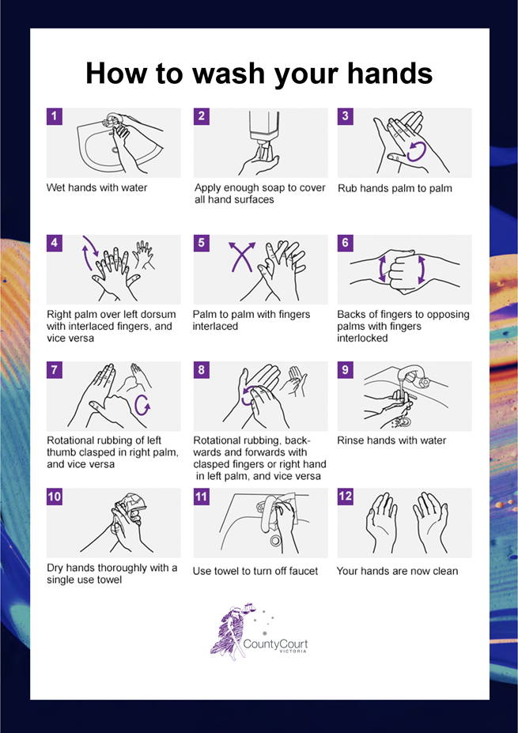

APPENDIX 2: Safe use of hand sanitiser protocol
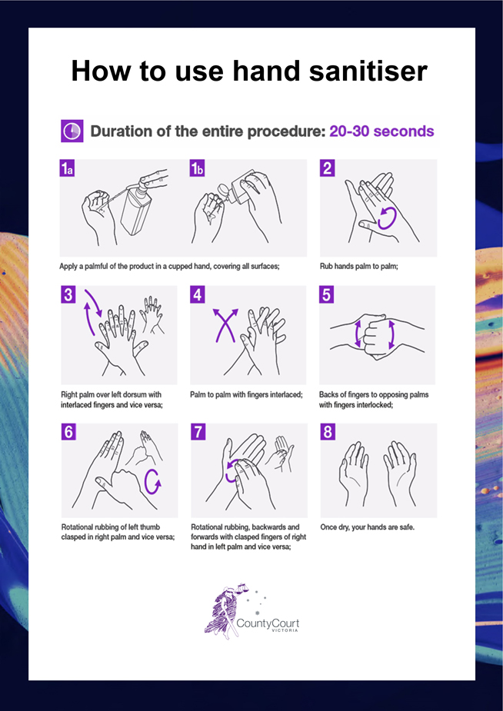

APPENDIX 3: Safe mask use and disposal protocol
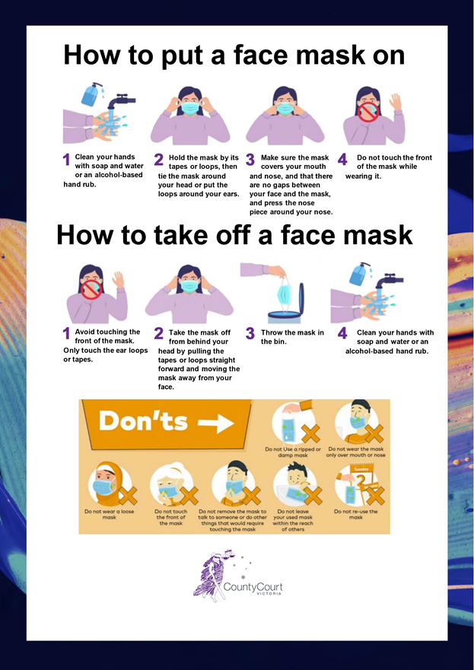
See ‘How to wear a mask’, Australian Government Department of Health: https://www.youtube.com/watch?v=rsBL0yTZNTM

APPENDIX 4: Safe glove use and disposal protocol
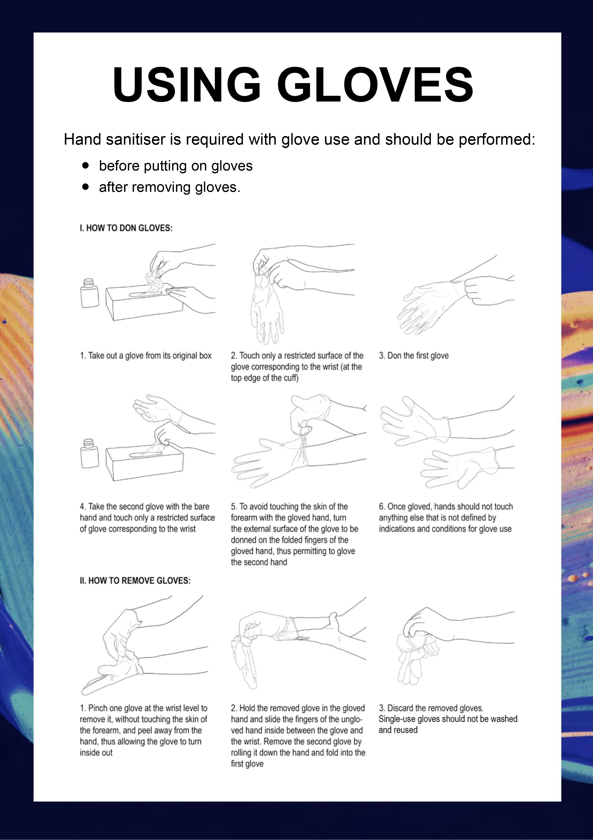
See Ansell’s video ‘How to properly remove single-use gloves’.

APPENDIX 5: Safe use of face shield protocol
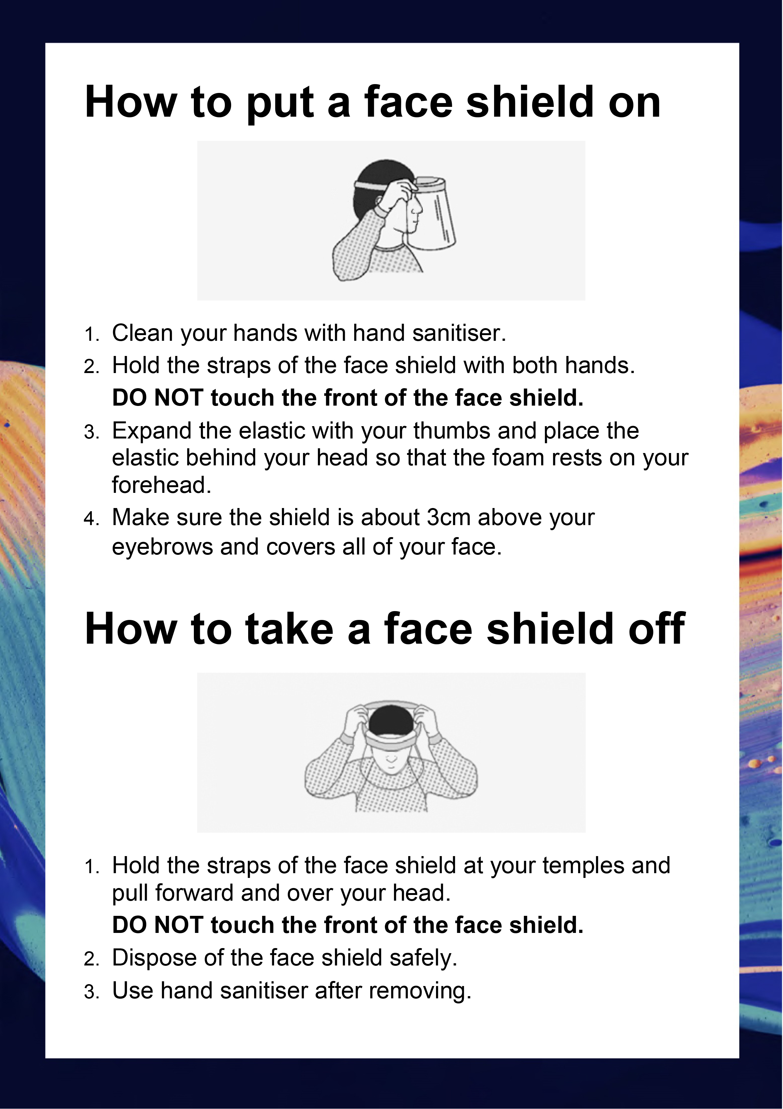

Note, this protocol is only for use of face shields in the circumstances described in 3.23 regarding in-person witnesses on pages 8–9.

