|  |  |
| --- | --- |
| Criminal Division Hearings – Zoom Information Guide |  |
|  |  |

**DOCUMENT CONTROL**

**Details**

|  |  |
| --- | --- |
| **Document type** | Information Guide |
| Reference | Criminal Division Hearings – Zoom Information Guide |
| Division | Criminal Division |
| Authorised by | Chief Judge Kidd |

**Release history**

|  |  |  |
| --- | --- | --- |
| Version | Date | Summary of changes |
| 1 | 10/12/2020 | N/A |
| 2 | 02/02/2021 | Section 5 amended to include online registration for the 9:00am General Crime List, 9:00am Sexual Offences List and 9:30am Circuit Directions Hearing List. |

Table of Contents

1. Overview 4

2. Zoom Technology Requirements to be a Zoom Host 5

3. When Will Zoom be Used in Criminal Hearings? 6

4. Who Will be Permitted to Join a Zoom Hearing? 7

5. Prior to the Hearing 8

6. Joining the Hearing via Zoom 9

Email Invitation 10

Zoom Desktop App 11

Mobile Device (smartphone or tablet) 12

Web Browser 13

Telephone Appearance 13

7. How to Change Your Virtual Background 14

How to Change Your Virtual Background Before You Join a Meeting 14

How to Change Your Virtual Background During a Meeting 15

8. During the Hearing 16

9. Calling or Tendering Evidence 17

10. Sharing Material – Displaying evidence 18

11. Recording and Transcription 20

12. Formalities and the Law 20

13. Questions or Issues 21

Annexure A 22

# Overview

* 1. Hearings in the Criminal Division of the County Court (‘the Court’) may be conducted utilising Zoom Meetings (‘Zoom’). Zoom is an audio and visual conferencing platform which will facilitate appearances or attendances at the hearing remotely. Zoom will be used in conjunction with traditional video-link technology and physical attendance at the Court, where required.
  2. A Zoom hearing is a hearing that involves some participants appearing or observing remotely through Zoom.
  3. A Zoom hearing can be linked to in-court technology, in addition to traditional video-links. This allows participants or others to attend or observe a hearing in a number of different ways simultaneously.
  4. An important objective of the Court, at this time, is to reduce the number of people who are physically attending at the Court. Technology, including Zoom and video-links, will be used to meet this objective.

# Zoom Technology Requirements to be a Zoom Host

* 1. Zoom is an audio and visual conferencing platform that can be used from any smart device, including computers, tablets and smartphones. You can access Zoom through the Zoom app on your smart device, or through an internet browser on your device.

To access Zoom you will need one of the following:

**System Requirements**

* An internet connection – broadband wired or wireless connection (where possible, a broadband internet connection is recommended)
* Speakers and a microphone – built-in or USB plug-in or wireless bluetooth
* A webcam – built-in to your device or USB plug-in

**Supported Operating Environments**

* Windows – 7, 8 (classic), 8.1 (classic), and 10 (Home, Pro, or Enterprise)
* Mac – macOS X with macOS 10.9 or later

**Supported Web Browsers**

* Windows: IE 11+, Edge 12+, Firefox 27+, Chrome 30+
* Mac: Safari 7+, Firefox 27+, Chrome 30+

**Supported Devices**

* Computer – Windows or Apple computer with web-camera, speakers and a microphone
* iPhone and iPad – iOS 8.0 and later
* Android devices – Lollipop 5.0 and later
  1. The Court will be the Zoom host. Participants do not require a hosting account to appear or attend by a County Court Zoom video/audio meeting (‘Zoom hearing’). Attending Zoom hearings is **free** for participants.
  2. To join a Zoom video/audio meeting hosted by the Court, participants should download the Zoom Meetings application (‘app’) on their chosen device. The Zoom Meetings application may be downloaded for free from [here](https://zoom.us/download).[1]
  3. In order to participate in a Zoom hearing, the participant’s device must be connected to the internet. The quality of a Zoom connection is dependent on the quality of the internet connection. The Court encourages participants to access Zoom through a device from a location that has a reasonable internet connection, whether via Wi-Fi or a cellular network (for example, 4G).
  4. The Court recommends the use of a smart device (desktop, laptop or iPad) with a screen size no less than 9.7”, as seeing other participants is generally easier with a larger screen.
  5. The Court also recommends that participants joining the Zoom hearing remotely use a headset, or headphones with a built-in microphone. Doing so will reduce background noise from disrupting the hearing and will keep distractions to a minimum. It will also prevent a feedback loop of sound from occurring.
  6. Participants can join a Zoom hearing through Zoom via the desktop app, from a calendar invite or via the mobile app.
  7. If determined appropriate by the presiding judge, participants may join a Zoom hearing by telephone, joining by audio only.

# When Will Zoom be Used in Criminal Hearings?

* 1. Hearings in the Criminal Division will be conducted in accordance with the relevant Criminal Division Emergency Protocols COVID-19 issued by the Court.
  2. The below general matters[2] are subject to, and must be read in conjunction with, the Criminal Division Emergency Protocols COVID-19 issued by the Court.
  3. Participants should refer to Annexure A of this Information Guide for a snapshot as to the types of remote hearings that will be conducted via Zoom.
  4. Judges (or judicial registrars)[3] may also identify matters that are suitable to conduct by way of Zoom and direct that a participant or participants appear through Zoom. Judges may also allow participants or others to observe the hearing of a matter by joining the Zoom hearing.[4]
  5. Counsel, instructing solicitors, or a self-represented accused, may also make a request to the presiding judge through the associate that:

1. a suitable matter be conducted using Zoom;
2. participant(s) appear at the hearing through Zoom; and/or
3. others observe the hearing through Zoom.[5]
   1. In determining whether to utilise Zoom, the Court will take into account:
4. The objective of the Court to reduce the number of people physically attending at the Court;
5. That the technology enables all appropriate persons to see and/or hear participants involved in the hearing, including during the giving of evidence or making of submissions.[6]
   1. Ultimately, it is at the discretion of the presiding judge to determine whether:
6. a matter is suitable to hear via Zoom; or
7. participant(s) should appear, attend or observe via Zoom.

# Who Will be Permitted to Join a Zoom Hearing?

* 1. Where appropriate, a judge[7] (and/or their staff) may appear remotely, that is, outside of a courtroom, via Zoom.
  2. If directed by the judge, participants that can appear at a Zoom hearing include:

1. counsel;
2. instructing solicitors;
3. the accused person;
4. the complainant or victim;
5. the informant, or other members of Victoria Police;
6. Corrections Victoria, including prison or Corrections’ officers;
7. witnesses, including expert witnesses;
8. interpreters; and
9. intermediaries.
   1. If directed by the judge, others may be able to join a Zoom hearing for the purposes of observing including:
10. family members/support persons of the accused or complainant/victim; and
11. an accredited media representative. See the Court’s Media Accreditation Policy [here](https://www.countycourt.vic.gov.au/files/documents/2019-09/media-accreditation-policy-2019.pdf.).[8]
    1. In determining whether an accredited media representative or journalist may join a Zoom hearing for the purposes of observing, a relevant consideration will be the principle of open justice (though, the Court notes that the use of Zoom does not involve a closing of the Court). Other relevant considerations will be that, at the discretion of the presiding judge, the Court will also continue to make recordings of sentences available on the media portal for accredited journalists, sentencing remarks will continue to be published (including utilising the Immediate Publication Protocol), and that, in limited circumstances, it may also be possible for journalists to attend Court, including to film sentences for broadcast.
    2. As with other media requests, these should be directed by email to the County Court Media team ([CCVmedia@courts.vic.gov.au](mailto:CCVmedia@courts.vic.gov.au)) and not individual judges’ chambers.

# Prior to the Hearing

* 1. At least seven days before the hearing, parties must file a remote hearing notification form. This notification form will advise the chambers of the presiding judge of matters including:

1. The email address and phone number of each participant or observer who will be joining the hearing via Zoom. The email addresses will be used to send a Zoom hearing invitation.
2. A realistic estimate of the duration of the hearing.
3. If a party intends on calling a witness, the witness’ email address and phone number will also need to be provided.
   1. The remote hearing notification form must be used for all types of hearings, whether conducted via Webex or Zoom with the exception of the types of hearings specified in paragraphs [5.3] and [5.4] below.
   2. At least seven days before the hearing, parties must file the:
4. Contravention of community correction order (‘CCO’) Webex notification form for contravention of CCO hearings;
5. Judicial monitoring hearing Webex notification form for judicial monitoring hearings.
   1. Anyone seeking to attend a virtual hearing or eHearing in any of the following List Courts must register their attendance, at least two days before the hearing, by completing an online registration form for the relevant List:
6. 9:00am General Crime List;
7. 9:00 Sexual Offences List;
8. 9:30am Circuit Directions Hearing List.

Online registration links for the relevant List Courts specified in paragraph [5.4 (a) - (c)] are available on the Court’s website: <https://www.countycourt.vic.gov.au/going-court/virtual-hearings-and-trials>

For all other criminal virtual hearings and eHearings heard in the 10:30am General Crime List and 10:30am Sexual Offences List, a remote hearing notification form must be filed in accordance with paragraphs [5.1] and [5.2] above.

* 1. The Court recommends that participants test and verify that their smart device is working, and their video and audio are set up correctly, well in advance of any scheduled hearing. For the desktop and mobile apps, a test meeting can be conducted by clicking [here](https://zoom.us/test).[9]
  2. The presiding judge’s chambers will email participants a Zoom hearing invitation that can be used to join the Zoom hearing. This invitation must be accepted.
  3. It is anticipated that the Zoom invitation will invite participants to join the Zoom hearing approximately 10-15 minutes before the scheduled hearing will commence, to allow for testing.

# Joining the Hearing via Zoom

* 1. The Zoom hearing can be joined from the email invitation sent by the Court, or through the Zoom Meetings desktop, mobile or web application.
  2. The Court recommends that, before the hearing, participants prepare by downloading the Zoom Meetings app which can be downloaded [here](https://zoom.us/download).[10]
  3. However, if first time participants have not downloaded the Zoom app before they seek to join a Zoom hearing, they will be prompted to download and install the Zoom Meetings app from their smart device after clicking on the ‘Join meeting’ button from their email invitation. When prompted, download and install the Zoom Meetings app.
  4. The steps to join a Zoom hearing depend on how the participant will be joining – whether by:

1. email invitation;
2. using a desktop app;
3. using a mobile (smartphone or tablet) app;
4. using the web-based application; or
5. Please note, the Zoom browser has some limitations for participants, and is not suitable for criminal trials.

Specifically, when the Court ‘Spotlights’ a witness (to record the evidence of a witness in ‘witness only view’) a browser participant’s view of the courtroom will be swapped with a large video of themselves on the screen. The browser participant is then able to hear the judge and counsel but is unable see them. When joining via the Zoom app, this problem is addressed as it is possible to readjust the video layout to an alternate view.

1. using a telephone (audio only).
   1. Each of these is discussed below.
   2. In the Court’s experience, for those who will not be using Zoom regularly, joining a Zoom hearing by using the email invitation is the most straightforward way to do so.
   3. Participants will not be able to join the Zoom hearing using the steps below, unless the host (the Court) has started the meeting. This is so even if participants attempt to join the hearing at the stipulated time in the invitation.

### Email Invitation

1. Once accepted, the invitation will create a calendar event in the participant’s calendar.
2. Open the calendar event. This will create a pop-out window, containing a **URL** (**Figure A**).
3. Click the **URL** to join the hearing.
4. If this is the first time the participant is using Zoom, the participant will need to enter their name and email address and click **Join**.
5. This will then re-direct the participant to a further Zoom window, which will provide a preview of how the participant will be seen by others as well as the ability to adjust their audio/visual settings and background. From this window, the participant will need to click the blue button. This allows a participant to join the Zoom hearing (**Figure B**).
6. After the participant joins, they will be able to see and hear other participants appearing by Zoom, and through a bridging link any participants appearing by video-link or in court.
7. 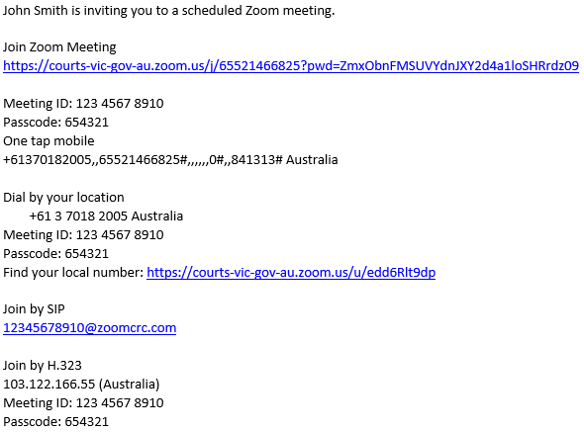Participants can click [here](https://support.zoom.us/hc/en-us/articles/201362193-Joining-a-meeting#:~:text=Go%20to%20join.zoom.us,client%20to%20join%20the%20meeting.)[11] for further instructions on how to join a Zoom hearing from an email invitation.



**Figure B**

**Figure A**

### Zoom Desktop App

1. If this is the first time the participant is using the Zoom Meetings desktop app, the participant will be prompted to enter their name and email address and click **Next**.
2. Participants are not required to sign in first but may wish to do so if they have created a Zoom account. Alternatively, participants can use the Zoom Meetings desktop app as a guest.
3. To join a Zoom hearing by way of the desktop app, open the desktop app and click **Join** (**Figure C**) and enter the meeting ID number and your display name, and click to enter the meeting (**Figure D**).
4. The Court may require that participants use a meeting password (which is found in the email invitation). If prompted, enter the password and click **Join meeting**.
5. Then click **Join meeting** to attend the Zoom hearing.
6. Participants can set-up and test their [audio and video settings](https://support.zoom.us/hc/en-us/articles/201362283-Testing-computer-or-device-audio)[12] as required once they have joined the meeting.
7. Participants can watch a YouTube video on how to join a Zoom hearing through the desktop app by clicking [here](https://youtu.be/hIkCmbvAHQQ).[13]
8. 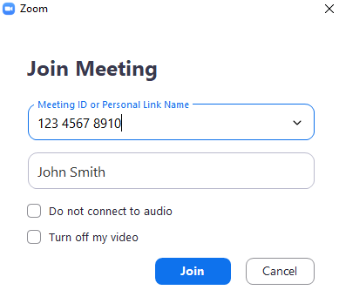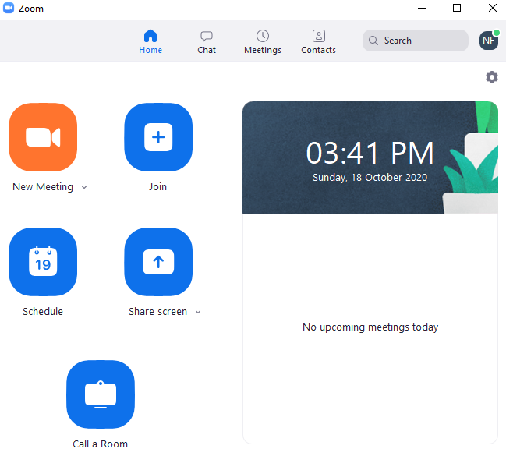Alternatively, participants can click [here](https://support.zoom.us/hc/en-us/articles/201362193-Joining-a-meeting)[14] for instructions on how to use the Cisco Zoom Meetings Desktop App as a guest.

**Figure D**

**Figure C**

### Mobile Device (smartphone or tablet)

1. Participants should open the mobile app and tap . Participants are not required to sign in first but may wish to do so if they have created a Zoom account (**Figure D**).
2. Enter the meeting number (in the email invitation) and name, and tap .
3. The Court may require that participants use a meeting password (in the email invitation). Enter the meeting password (in the email invitation) and tap **Join** (**Figure E**).
4. Participants can set up their [audio and video settings](https://support.zoom.us/hc/en-us/articles/201362283-Testing-computer-or-device-audio)[15] as required.
5. Click **Join** to attend the Zoom hearing.
6. 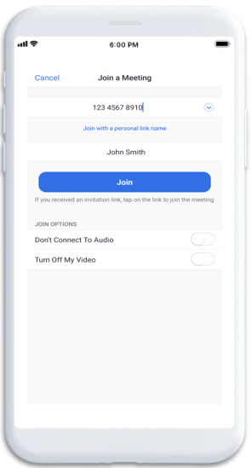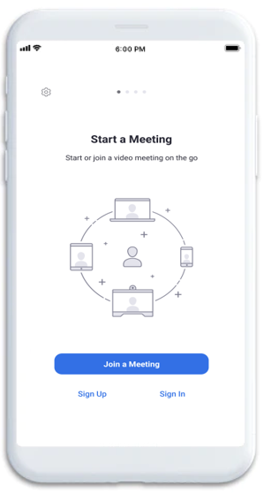Alternatively, participants can click [here](https://support.zoom.us/hc/en-us/articles/201362193-Joining-a-meeting)[16] for instructions on how to connect to Zoom hearings from a mobile device.

**Figure E**

**Figure D**

### Web Browser

1. Click the **Join meeting** button in your email invitation to join the Zoom hearing.
2. 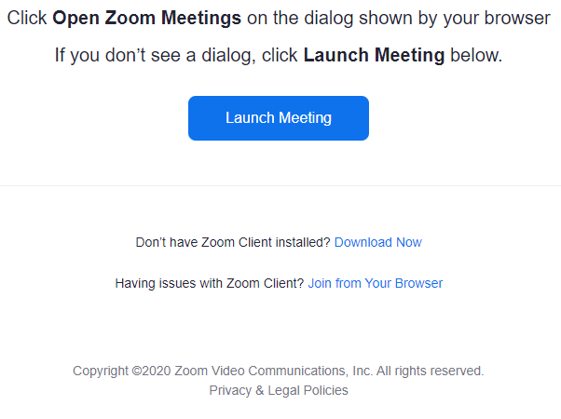Click **Join from your browser** (**Figure F**).

**Figure F**

1. The participant is to enter their name and click **Join**.
2. The Court may require participants to use a meeting password. Enter the meeting password (which is found in the email invitation) and tap **OK**.
3. Participants can set up their [audio and video settings](https://help.webex.com/en-us/nt2ig0y/Choose-Your-Audio-and-Video-Settings-Before-You-Join-a-Webex-Meeting-or-Event)[17] as required.
4. Participants can click [here](https://support.zoom.us/hc/en-us/articles/201362193-Joining-a-meeting)[18] for instructions on how to connect to Zoom hearings from a web browser.

### Telephone Appearance

1. Some participants may need to appear or attend at the Zoom hearing by telephone.
2. This can occur by the participant dialling the Court.
3. If the participant is connecting to the Court via telephone, the **email invitation** contains the details for the participant to call into the Zoom hearing (**Figure G**).
4. 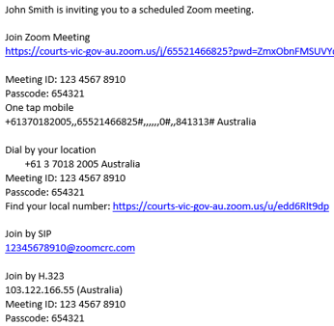The participant will need to dial the telephone number noted in the email invitation (03 7018 2005).
5. The participant will then be prompted to enter the Meeting ID (also contained in the email invitation) followed by the **#** button.
6. The participant will then be linked to the hearing by audio only.
7. Please note, the phone number of participants dialling into a Zoom hearing will be hidden from other participants (for example: 863****15).

**Figure G**

# How to Change Your Virtual Background

* 1. The Court has made a number of courtroom backgrounds available that may be used by members of the legal profession when participating in County Court virtual hearings and trials.
  2. Members of the legal profession should only use the courtroom backgrounds provided by the Court, or a neutral background that is otherwise appropriate for appearing in court.

The courtroom virtual backgrounds can be downloaded from the County Court website under [Virtual hearings and trials](https://www.countycourt.vic.gov.au/going-court/virtual-hearings-and-trials).[19]

* 1. All other participants should use a neutral background that is appropriate for appearing in court.

### How to Change Your Virtual Background Before You Join a Meeting

* 1. ****To change your background before joining the Zoom hearing, select the icon to search for the image you would like to set as the virtual background (**Figure H**).

**Figure H**

* 1. 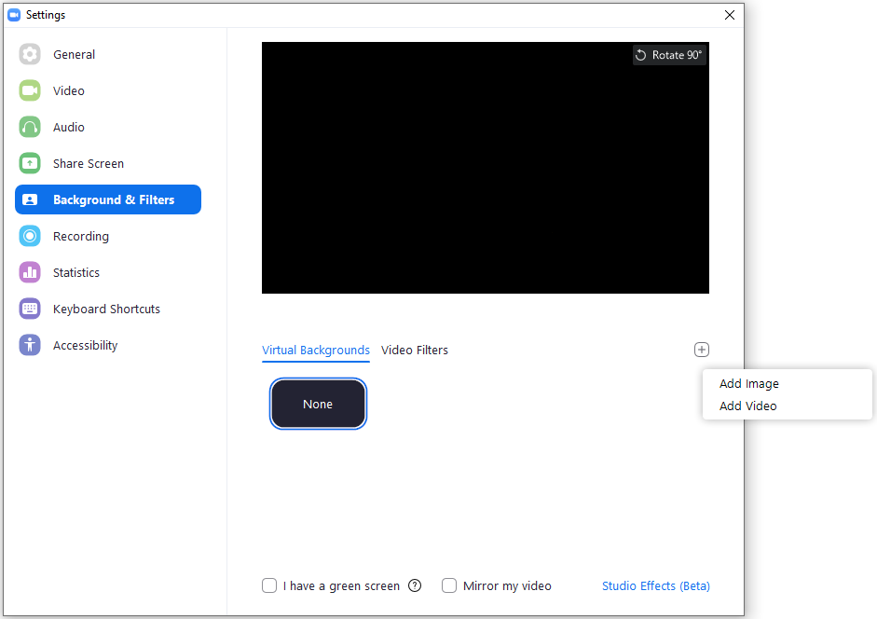Click on an image to select the desired virtual background or add your own image by clicking on the **+** symbol **Add Image**. Search for the image you would like to set as your virtual background and press **Open** (**Figure I**).

**Figure I**

* 1. If prompted, click **Download** to download the package for a virtual background without a green screen.
  2. The image you select will be saved to your computer and can be used again for later meetings. However, if would like to use the same image on another device, you will need to add it to your new device.

### How to Change Your Virtual Background During a Meeting

* 1. To change your background during the Zoom hearing, click **˄** next to start/stop video located in the control bar towards the bottom of the Zoom screen, and select **Choose Virtual Background** (**Figure J**).

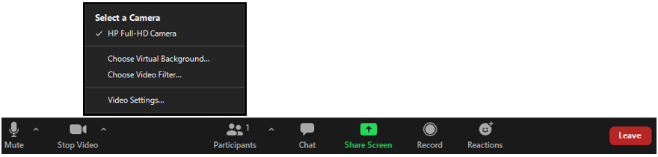

**Figure J**

* 1. Click on an image to select the desired virtual background or add your own image by clicking on the **+** symbol **Add Image**.
  2. If prompted, click **Download** to download the package for a virtual background without a green screen.
  3. Search for the image you would like to set as your virtual background and press **Open**.
  4. The image you select will be saved to your computer and can be used again for later meetings. However, if would like to use the same image on another device, you will need to add it to your new device.

# During the Hearing

* 1. As noted in paragraph [5.4], it is anticipated that the Zoom invitation will invite participants to join the Zoom hearing approximately 10-15 minutes before it is intended that the hearing will commence.
  2. During this pre-hearing time, the judge’s associate and/or tipstaff will conduct testing. Testing will be done to ensure the connection between the courtroom, Zoom and any video-links is working. In addition, this time will be to ensure that the audio and video of each participant is working and to troubleshoot and resolve any problems before commencing with the hearing.
  3. Participants should join from a quiet place, and as much as possible, somewhere that provides a neutral backdrop. This is to avoid unnecessary distraction, noise or identification of the participant’s location.

As noted in paragraphs [7.2] and [7.3], members of the legal profession should only use the courtroom backgrounds provided by the Court, or a neutral background that is otherwise appropriate for appearing in court. All other participants should use a neutral background that is appropriate for appearing in court.

* 1. The Court strongly recommends that participants wear a headset, or headphones with a built-in microphone to avoid background noise and to ensure that there is no sound feedback loop.
  2. Participants should mute their microphones when they are not speaking. To mute or unmute click **Mute** or **Unmute**  to turn your microphone off or on.
  3. Please note, if you are on mute and wish to contribute briefly, you do not need to unmute yourself. Instead, you can simply press and hold the **spacebar** button to toggle your microphone on, and then release it when you have finished speaking.
  4. If there is a need for counsel to confer with the accused, where they are remote from each other, the Court can place the participants into a separate room for a private discussion, outside of the main meeting using ‘breakout rooms’. Subsequently, the participants in the breakout room will be able to re-join the main meeting at any time, or the host will be able to bring them back after a scheduled time.
  5. For convenience, judges may direct participants to follow certain conventions to ensure the hearing proceeds smoothly (for example, raising a hand to speak). This will be a matter for the presiding judge.
  6. Unless otherwise directed by the presiding judge and with the exception of those matters specified in paragraph [9.9] below, the chat and share content functions will not be utilised in Zoom hearings. The Court has taken this position to avoid complicating the remote hearing process and to ensure that all participants can easily participate in the hearing without distraction.

# Calling or Tendering Evidence

* 1. Witnesses may appear at a hearing, and give evidence, by Zoom.
  2. Before the hearing, the party calling the witness will have provided the presiding judge’s associate with any witness’ email address and telephone number and an estimate of when the witness will need to join the hearing.

The witness’ details must be provided in the remote hearing notification form which must be filed, via eLodgement, at least seven days before the hearing.

* 1. During the hearing, at the appropriate time, the associate will send a Zoom invitation to the witness to join. The witness will need to accept using one of the methods in section 6 of this Information Guide. Once the witness does so, they will join the Zoom hearing along with all other participants.
  2. The witness will be sworn or affirmed by the judge’s staff (either appearing from court or remotely via Zoom).
  3. During the giving of evidence, both counsel may wish to have their microphones unmuted. This will allow the party calling the witness to question their witness and the other party to object.
  4. Once the witness’ evidence is completed, the judge will excuse the witness. The witness will need to click on the red button located at the bottom right of their Zoom screen. This will create a pop-up window, with an option to ‘Leave Meeting.’ The witness must then select **Leave Meeting**.
  5. The same process adopted for witnesses can also be adopted for interpreters and intermediaries if they are to appear via Zoom.
  6. Written material, submissions or proposed exhibits must be e-lodged in advance of the hearing. If it is not possible to do so, parties may email the judge’s associate and other parties with any written material and exhibits during the hearing.
  7. Any party seeking to share documents, media or proposed exhibits (herein collectively referred to as ‘material’) at a Zoom hearing must notify the chambers of the presiding judge, via email, at least *seven days* before the hearing date.

1. The party must specify the material and the time at which the material is sought to be shared.
2. At the Zoom hearing, it is the responsibility of the instructing solicitor to use the ‘share function’ (see section 10 below) to share any material relied upon. If the instructing solicitor is not available at the Zoom hearing, arrangements must be made with the Court in advance of the hearing and by contacting the chambers of the presiding judge.

# Sharing Material – Displaying evidence

* 1. If it is necessary to display material (documents, photographs, video, etc.) to a witness, the host and/or counsel may do so by way of the ‘Share Screen’ function within Zoom.
  2. Please note, to prevent the accidental exposure of something private (for example, a sensitive email, or a private instant message) when sharing your screen before several participants, the Court strongly advises parties against sharing their full screen/window and instead recommends:
* only sharing an individual application (PDF, Word, Windows Media Player etc.); and
* having the evidence (documents, photographs, and video etc.) open on your device prior to sharing your screen; and
* closing any unnecessary applications before sharing your screen.
  1. To share your screen, click the Share Screen button located in your meeting controls.
  2. 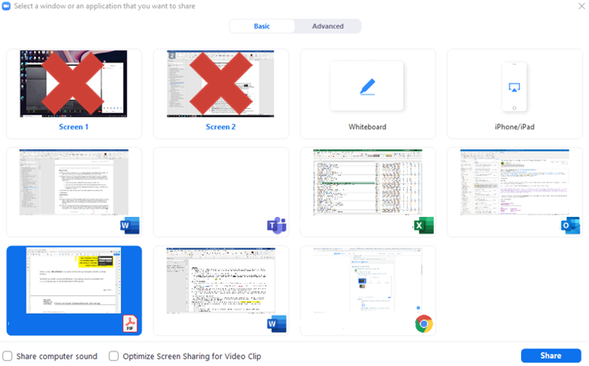Select the **application** you would like to share with the participants, and press **Share**.
  3. When you start sharing your screen, the meeting controls will move towards the top of the screen (you can drag the controls around your screen).

|  |  |
| --- | --- |
|  | **Mute/Unmute:** Click **Mute** or **Unmute** to turn your mic off or on. |
|  | **Start/Stop Video:** Click **Stop Video** or **Start Video** to turn your video off or on. |
|  | **Participants:** Click to show a list of participants in the meeting. |
|  | **New Share:** You will be able to start a new screen share. You will be prompted to select which application you want to share again. |
|  | **Pause Share:** Will pause your current shared screen. |
|  | **Annotate:** Participants can annotate on a shared screen. |
|  | **Remote Control:** The remote-control feature allows you to give another participant mouse/keyboard control to your device. Alternatively, other participants may also request to take control of your screen in a meeting.  Please note, this feature is limited to Zoom desktop clients for Windows, Mac, or Linux and/or iPads with Zoom mobile app |
|  | **More:** This will give you access to a number of options including chat, invite, record, hide video panels, leave meeting and so forth. |

* 1. To stop sharing your screen, select **Stop Share** at the bottom side of the meeting controls.

# Recording and Transcription

* 1. As noted in paragraph [1.3], a Zoom hearing can be linked to the in-court technology and video-links, allowing all participants to be joined in the same virtual hearing. This is the case even where a judge is sitting remotely.
  2. Where the Zoom hearing is linked to the in-court technology, the recording and transcription of the hearing can continue in the ordinary course. That is, the Victorian Government Reporting Service (‘VGRS’) can access, record and transcribe the hearings.
  3. A connection to the in-court technology will be the preferred approach adopted by the Court, unless it is not practicable to do so.
  4. In the event that a Zoom hearing cannot be linked to the in-court technology, then it is possible to record the participants who have joined the Zoom hearing, through the Zoom application. The host (the Court) has the capacity to record through Zoom. Other participants joining cannot record through Zoom.
  5. If a hearing is recorded through Zoom, the recording will be provided to VGRS, for VGRS to continue to archive and transcribe in the ordinary manner.

# Formalities and the Law

* 1. Judges may continue to preside over matters by sitting on the bench in the courtroom. However, there may be instances where a judge is presiding over a matter from a remote location (chambers or elsewhere).[20]
  2. Unless otherwise directed by the presiding judge, the usual formalities of a court hearing will continue to be followed. This includes opening the court, announcing the matter and the wearing of robes by the judge and his or her staff.
  3. Participants appearing remotely via Zoom are taken to be appearing as though they were present at court. This means that laws that would apply in court, including laws relating to evidence, procedure, contempt of court and perjury will continue to apply.[21]
  4. Participants joining via Zoom must note that this means it continues to be an offence to record a court hearing without permission of the Court.[22] As noted in paragraph [11.4], participants do not have the ability to record a hearing through Zoom, but participants must not use other means to record the Zoom hearing or take photos or screenshots of the Zoom hearing.

# Questions or Issues

* 1. For general and urgent support enquiries relating to Zoom, please contact the County Court eHearings Support Team on 8636 6472 or [CCV-eHearings.Support@courts.vic.gov.au](mailto:CCV-eHearings.Support@courts.vic.gov.au)
  2. Alternatively, please advise the associate to the presiding judge of any questions or issues, via email, as soon as practicable. The associate will assist you through Zoom, or through an alternative method where required.
  3. If you are experiencing complex technical issues, you should contact Zoom support. Zoom support can be accessed by clicking [here](https://help.webex.com/contact)[23] or via telephone on 1800 129 278.
  4. Zoom also offer several helpful video tutorials [here](https://help.webex.com/en-us/8bzter/Cisco-Webex-Meetings-Video-Tutorials)[24] about how to use Zoom Meetings.

|  |  |  |
| --- | --- | --- |
| **Hearing Type** |  |  |
| Plea |  |  |
| County Koori Court plea hearing |  |  |
| Sentence |  |  |
| Application for bail (including application for variation or revocation) |  |  |
| Judicial monitoring hearing |  |  |
| Contravention of CCO (including application to vary or cancel a CCO) |  |  |
| Sentence appeal |  |  |
| Case conference |  |  |
| Post-sentence supervision order matters under the *Serious Offenders Act 2018* |  |  |
| Hearings under the *Crimes (Mental Impairment and Unfitness to be Tried) Act 1997* (‘*CMIA*’) (other than fitness investigations and special hearings under the *CMIA*) |  |  |
| List Courts (including General Crime List, Circuit Directions Hearing List, Sexual Offences List, Long Trials List and County Koori Court Directions Hearing List) |  |  |
| Special hearing under the *Criminal Procedure Act 2009* (‘*CPA*’) |  |  |
| Pre-recorded evidence  (including s 198A and s 198B *CPA* hearings) |  |  |
| Jury trial |  |  |
| Trial by judge alone |  |  |
| Fitness investigation under the *CMIA* |  |  |
| Special hearing under the *CMIA* |  |  |
| Conviction appeal |  |  |

# Annexure A

1. <https://zoom.us/download>
2. Refer to [3.3] - [3.7].
3. Throughout this document a reference to Judge may also refer to a judicial registrar.
4. Section 42E of the *Evidence (Miscellaneous Provisions) Act* *1958*.
5. Throughout this document a reference to participants also refers to observers.
6. Section 42G of the *Evidence (Miscellaneous Provisions) Act* *1958*.
7. Section 3B of the *County Court Act 1958*.
8. <https://www.countycourt.vic.gov.au/files/documents/2019-09/media-accreditation-policy-2019.pdf>.
9. <https://zoom.us/test>
10. <https://zoom.us/download>
11. <https://support.zoom.us/hc/en-us/articles/201362193-Joining-a-meeting#:~:text=Go%20to%20join.zoom.us,client%20to%20join%20the%20meeting.>
12. <https://support.zoom.us/hc/en-us/articles/201362283-Testing-computer-or-device-audio>
13. <https://youtu.be/hIkCmbvAHQQ>
14. <https://support.zoom.us/hc/en-us/articles/201362193-Joining-a-meeting>
15. <https://support.zoom.us/hc/en-us/articles/201362283-Testing-computer-or-device-audio>
16. <https://support.zoom.us/hc/en-us/articles/201362193-Joining-a-meeting>
17. <https://help.webex.com/en-us/nt2ig0y/Choose-Your-Audio-and-Video-Settings-Before-You-Join-a-Webex-Meeting-or-Event>
18. <https://support.zoom.us/hc/en-us/articles/201362193-Joining-a-meeting>
19. <https://www.countycourt.vic.gov.au/going-court/virtual-hearings-and-trials>
20. See s 3B of the *County Court Act 1958*.
21. Section 42W of the *Evidence (Miscellaneous Provisions) Act* *1958*.
22. Section 4A of the *Court Security Act 1980*.
23. <https://help.webex.com/contact>
24. <https://help.webex.com/en-us/8bzter/Cisco-Webex-Meetings-Video-Tutorials>