Electronic submission of subpoenaed material
Instruction manual for Addressees

DOCUMENT CONTROL
Details
Document type | Instruction manual
Reviewed by | Subpoena Managers
Authorised by | Subpoena Managers
Notes | This process was developed in response to coronavirus (COVID-19).

Release history
Version | Date | Author | Summary of changes
1.0 | 23/04/20 | Business Analyst – Digital Transformation | Document created
1.1 | 15/05/20 | Manager, Subpoenas | Updates to chapter 5

Related documents
Document title | Version
Instruction manual Parties and Practitioners | 1
Notice to Addressees | 1
Notice to Parties and Practitioners | 1

CONTENTS
1. Purpose 4
2. Scope 4
3. Overview of the process 4
4. How to access Microsoft OneDrive 5
Creating an account 5
Signing in 5
5. How to upload material 5
6. How to create a link to share material 7
7. How to remove material from your OneDrive account 8
8. Questions 9

Purpose
  - In response to COVID-19 the County Court (the Court) is seeking to minimise physical contact in relation to the subpoena management process. The Court has developed a process for the electronic submission of subpoenaed material by Addressees, which will minimise the need to attend the Court or submit material via post. This document serves as a how-to-guide on how to submit subpoenaed material to the Court electronically.

Scope
  - This process applies to all material that is able to be submitted in electronic form. If you are unable or unwilling to submit subpoenaed material using this process, you may be able to submit this material in hard copy or via CD/USB. Please contact the Subpoena team on 03 8636 6525 for the best alternative solution.

Overview of the process
  - If you have been served with a subpoena, you must comply by providing the subpoena or a copy of it and the documents or things specified in the schedule from the second page of the subpoena, to the Court.
  - Once you have gathered all relevant documents and things in relation to the subpoena, you may submit this to the Court electronically following these steps:
    - Create or sign into your Microsoft OneDrive account
    - Upload the subpoenaed material to your OneDrive.
    - Upload a copy of the subpoena, including the completed ‘Declaration by Addressee’ (last page of the subpoena) to your OneDrive.
Note: in the current circumstances, the Court acknowledges that signing the ‘Declaration by Addressee’ may be difficult. As such, the Court will accept a digital declaration without a signature, as long as all other details have been completed.
    - Upload a separate document with any objection, including the grounds for that objection.
    - Create a link to the material, the subpoena and any objection.
    - In the ‘Add a message’ field, ensure you include the case number, the name of the Addressee and whether an objection is being lodged.
    - Share the link with CCVsubpoenas@courts.vic.gov.au. Ensure the permissions are set to ‘anyone with this link’.
  - The Subpoena team will respond to your email with the link, confirming that the material has been processed. Once you have received this confirmation email, the Court encourages you to remove the material from your OneDrive account in order to free up space and minimise any risk of data leakage
  - If the documents or things are not in your possession, please email CCVsubpoenas@courts.vic.gov.au, advising that you have no records to produce. Please ensure you include the Case number (at the top right of the subpoena) and the name of the Addressee in that email.

How to access Microsoft OneDrive

Creating an account
  - In order to use Microsoft OneDrive, you must have a Microsoft account. If you use any of these services, you have a Microsoft account and can use this to sign in to OneDrive: Outlook, MS Office, Skype, OneDrive, Xbox Live, Bing, Store, Windows, or MSN.
  - If you do not use any of the above services, you can create a free Microsoft account online by following these steps:
    - On your computer, go to: https://onedrive.live.com/signup
    - Enter your email address or use a phone number instead and click ‘Next’
    - Note: you are able to use any type of email address (e.g. subpoenas@gmail.com). If you do not wish to use your existing email address, you can request a new email address by clicking ‘Get a new email address’
    - Enter your preferred password (ensure this is a strong password, including lowercase and uppercase alphabetic characters, numbers and symbols) and click ‘Next’
    - Enter your first and last name and click ‘Next’
    - Enter your date of birth and update your country/region if required
    - Verify your account by entering the verification code sent to your email address (e.g. subpoenas@gmail.com)
    - You may be prompted to enter characters displayed on the screen to verify that you are a real person
    - Once you have finished these prompts, your account will be created and you will be taken directly to your OneDrive account.

Signing in
  - You can sign in to OneDrive with your Microsoft account. To access OneDrive, follow these steps:
    - On your computer, go to: https://onedrive.live.com/about/en-au/signin/
    - Enter your email address (or other type of Microsoft account, such as phone number) and click ‘Next’
    - Enter your password and click ‘Sign in’
    - You will be sent directly to your OneDrive account and can start uploading material.

How to upload material
  - After you have signed in, follow these steps to upload documents to OneDrive:
    - Compile the relevant material to be produced in response to the subpoena and add this to a local folder on your computer.
Note: The Court asks that all material is combined into one file (preferably PDF). If you are producing both a redacted and unredacted version, the Court asks that all redacted material is combined into one file and all unredacted material is combined into another file, each clearly named ‘redacted’ or ‘unredacted’. If combining the material is not possible, the Court asks that material is added to a folder, separate from the subpoena and any objection.
    - Complete the ‘Declaration by Addressee’ (last page of the subpoena) and ensure you have a digital copy of this and the related subpoena.
    - Create a folder for the case you will be producing subpoenaed material for. This makes it easier to share and subsequently delete when the material is no longer required. To create a folder, click ‘New’ and then ‘Folder’ 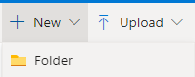. The Court encourages you to use the Court’s case number as the name of this folder. Click ‘Create’.
    - To upload material to this folder, simply drag your local folder (or folders) and drop this onto your OneDrive folder:
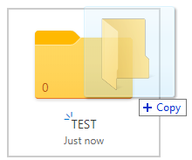.
Alternatively, open the OneDrive folder and click ‘Upload’ near the top of the page and then ‘Folder’ and select the relevant folder from your local source.
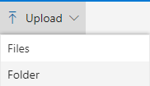
    - Upload the subpoena with the completed declaration to the OneDrive folder, keeping this separate from the subpoenaed material
    - Upload any objection to the OneDrive folder, keeping this separate from the subpoenaed material and the subpoena.
Your OneDrive folder will look something like this:
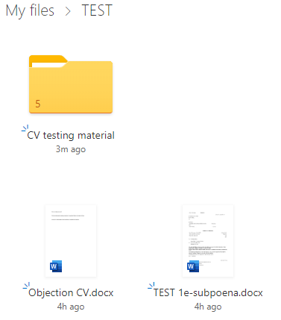

If you have uploaded both redacted and unredacted material, your OneDrive folder will look something like this:
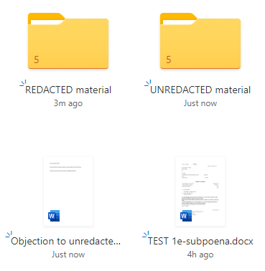
    - Once you have uploaded all the relevant material, the subpoena including the completed declaration and any objection to inspection, you can share the material with the Subpoena team.

How to create a link to share material
  - Follow the steps below to create a link in order to share subpoenaed material.
Note: your organisation’s administrator may have disabled sharing with external users in some way (either completely, or for example by allowing sharing with specific people only). If this is the case and you would like to use this solution, please contact your administrator to enable sharing with the Court.
    - Select the OneDrive folder
    - Clink ‘Share’ near the top left of your screen
    - Links are defaulted to ‘Anyone with the link can edit’. Depending on your account type, you are able to set up certain security levels, such as password protection, allowing access to specified persons only (only specified email addresses can access the material via the link) and expiration dates. If you choose to utilise any of these advanced security settings, please ensure you advise the Subpoena team so that they are able to easily access and process your submission. You can access these settings by clicking ‘Anyone with the link can edit’. Once you have setup your security settings, click ‘Apply’. Where possible, the Court suggests using the ‘Anyone with this link’ setting as this allows the individuals within the subpoena team to access and process these records.
    - 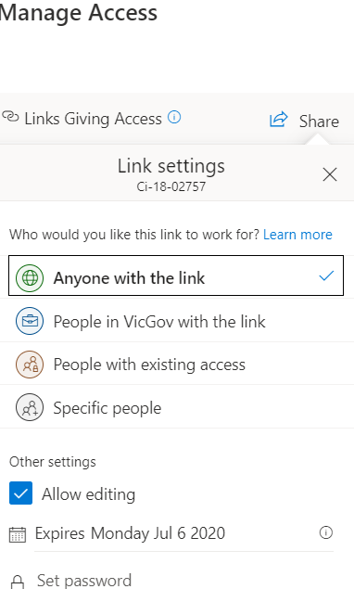.
    - Enter CCVsubpoenas@courts.vic.gov.au in the ‘Enter a name or email address’ field.
    - In the ‘Add a message (optional)’ field, ensure you include the case number, the name of the Addressee and whether an objection is being lodged.
Your link will look something like this:
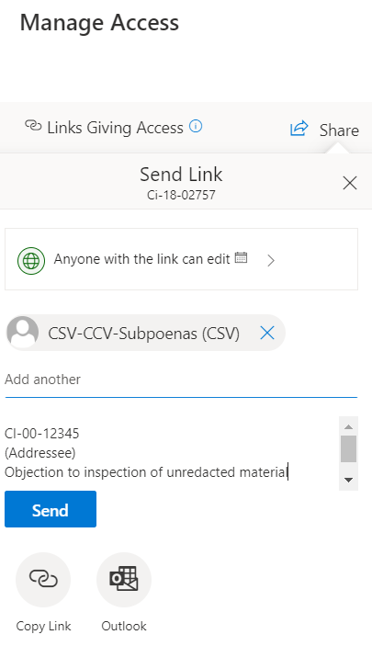

    - If you are happy with this link, click ‘Send’. A link to the material will then be sent to CCVsubpoenas@courts.vic.gov.au. Material will be available through this link as long as the link has not expired, and material is not removed from your OneDrive account.
Note: The Subpoena team will respond to your email with the link, once the material has been successfully processed. The Court encourages Addressees to remove material from their OneDrive account once this confirmation material has been received, in order to maximise data security.

How to remove material from your OneDrive account
  - Once material has been successfully processed by the Subpoena team and you have received confirmation, you may wish to remove material from your OneDrive account in order to free up space and maximise security. To remove material from your OneDrive account, follow these steps:
    - Open the OneDrive folder in ‘My files’
    - Select all material within this folder
    - Select ‘Delete’ near the top left/centre of your screen
    - If the deletion was successful, you will receive the following notification on your screen: 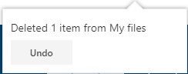
    - Once the folder is empty, go back to ‘My files’ and select the folder.
    - Complete steps (c) and (d) for the folder. Once this is completed, the folder should no longer be visible in ‘My files’
    - This folder remains recoverable in the Recycle bin for a number of days. If you wish to permanently delete this, follow the next steps.
    - Access your Recycle Bin through the menu on the left of your screen
    - Select the folder you wish to delete and click ‘Delete’ near the top left of your screen. Alternatively, you can empty the entire recycle bin by clicking on near the top left of your screen.
    - Confirm you wish to permanently delete the folder by clicking ‘Delete’ in the pop-up notification (or ‘yes’ if emptying the recycle bin).
    - Depending on the type of Microsoft account, you may also have a ‘second-stage’ recycle bin. To empty this, if prompted, click on ‘Second-stage recycle bin’ and follow steps 6 and 7 again.
    - Material has now been removed from OneDrive and is no longer accessible.

Questions
  - If you have any issues or concerns or require further information on the electronic submission of subpoenaed material, please contact the Subpoena team on 03 8636 6525 or via email at CCVsubpoenas@courts.vic.gov.au.

