Criminal Division Hearings – Webex Information Guide
September 2020 (Version 2)

DOCUMENT CONTROL
Details
Document type | Information Guide
Reference | Criminal Division Hearings – Webex Information Guide
Division | Criminal Division
Authorised by | Chief Judge Kidd

Release history
Version | Date | Summary of changes
1 | 09/04/2020 | N/A
2 | 11/09/2020 | New section 7 ‘How to Change Your Virtual Background’ has been inserted.

Table of Contents
1. Overview 4
2. Webex Technology Requirements to be a Webex Host 4
3. When Webex Will be Used in Criminal Hearings? 5
4. Who Will be Permitted to Join a Webex Hearing? 6
5. Prior to the Hearing 7
6. Joining the Hearing via Webex 7
Email Invitation 8
Webex Desktop App 9
Mobile Device (smartphone or tablet) 10
Web-Interface 11
Telephone Appearance 11
7. How to Change Your Virtual Background 12
How to Change Your Virtual Background Before You Join a Meeting 12
How to Change Your Virtual Background During a Meeting 13
8. During the Hearing 13
9. Calling or Tendering Evidence 14
10. Recording and Transcription 15
11. Formalities and the Law 15
12. Questions or Issues 16

Overview
  - Hearings in the Criminal Division of the County Court (‘the Court’) may be conducted utilising Cisco Webex Meetings (‘Webex’). Webex is video-conferencing software which will facilitate appearances or attendances at the hearing remotely. Webex will be used in conjunction with traditional video-link technology and physical attendance at the Court, where required.
  - A Webex hearing is a hearing that involves some participants appearing or observing remotely through Webex.
  - A Webex hearing can be linked to in-court technology, in addition to traditional video-links. This allows participants or others to attend or observe a hearing in a number of different ways simultaneously.
  - An important objective of the Court at this time is to reduce the number of people who are physically attending at the Court. Technology, including Webex and video-links, will be used to meet this objective.

Webex Technology Requirements to be a Webex Host
  - Webex is an audio and visual conferencing platform that can be used from any smart device, including computers, tablets and smartphones. You can access Webex through the Webex app on your smart device, or through an internet browser on your device.
To access Webex you will need one of the following:
System Requirements
- An internet connection – broadband wired or wireless connection (where possible, a broadband internet connection is recommended)
- Speakers and a microphone – built-in or USB plug-in or wireless bluetooth
- A webcam – built-in to your device or USB plug-in
Supported Operating Environments
- Windows – 7, 8 (classic), 8.1 (classic), and 10 (Home, Pro, or Enterprise)
- Mac – macOS X with macOS 10.9 or later
Supported Web Browsers
- Windows: IE 11+, Edge 12+, Firefox 27+, Chrome 30+
- Mac: Safari 7+, Firefox 27+, Chrome 30+
Supported Devices
- Computer – Windows or Apple computer with web-camera, speakers and a microphone
- iPhone and iPad – iOS 8.0 and later
- Android devices – Lollipop 5.0 and later
  - The Court will be the Webex host. Participants do not require a hosting account to appear or attend by a County Court Webex video/audio conference (‘conference’). Attending conferences is free for participants.
  - To join a Webex video/audio conference hosted by the Court, participants should download the Webex Meetings Desktop application (‘app’) on their chosen device. The Webex Meetings application may be downloaded for free from here.
  - In order to participate in a Webex hearing, the participant’s device must be connected to the internet. The quality of a Webex connection is dependent on the quality of the internet connection. The Court encourages participants to access Webex through a device from a location that has a reasonable internet connection, whether via Wi-Fi or a cellular network (for example, 4G).
  - The Court recommends the use of a smart device (desktop or laptop or iPad) with a screen size no less than 9.7”, as seeing other participants is generally easier with a larger screen.
  - The Court also recommends that participants joining the Webex conference remotely use a headset, or headphones with a built-in microphone. Doing so will reduce background noise from disrupting the hearing and will keep distractions to a minimum. It will also prevent a feedback loop of sound from occurring.
  - Participants can join a Webex hearing through Webex via the desktop app, from a calendar invite or via the mobile app.
  - If determined appropriate by the presiding judge, participants may join a Webex hearing by telephone, joining by audio only.

When Webex Will be Used in Criminal Hearings?
  - Hearings in the Criminal Division will be conducted in accordance with the relevant COVID-19 criminal division protocols issued by the Court. The below general matters are subject to and must be read in conjunction with the COVID-19 Criminal Division protocols issued by the Court.
  - Judges (or judicial registrars) may identify matters that are suitable to conduct by way of Webex and direct that a participant or participants appear through Webex. Judges may also allow participants or others to observe the hearing of a matter by joining the Webex conference.
  - Counsel or instructing solicitors, or a self-represented accused, may also make a request to the judge’s associate that:
- a suitable matter be conducted using Webex;
- participant/s appear at the hearing through Webex; and/or
- others observe the hearing through Webex.
  - In determining whether to utilise Webex, a relevant consideration will be that it is an objective of the Court to reduce the number of people physically attending at the Court. Another relevant consideration will be that the technology enables all appropriate persons to see and/or hear participants involved in the hearing, including during the giving of evidence or making submissions.
  - Ultimately, it is for the presiding judge, in his or her discretion, to determine whether a matter is suitable to hear using Webex, or whether an individual participant or participants should appear, attend or observe by Webex.

Who Will be Permitted to Join a Webex Hearing?
  - Where appropriate, a judge (and/or their staff) may appear remotely, that is, outside of a courtroom, via Webex.
  - If directed by the judge, participants that can appear at a Webex hearing include, but is not limited to:
- counsel;
- instructing solicitors;
- the accused person;
- the victim or complainant;
- the informant, or other members of Victoria Police;
- Corrections Victoria, including prison or Corrections’ officers;
- witnesses, including expert witnesses
- interpreters; and
- intermediaries.
  - If directed by the judge, others may be able join a Webex hearing for the purposes of observing including:
- family members/support persons of the accused or victim/complainant; and
- an accredited media representative. See the Court’s Media Accreditation Policy here.
  - In determining whether an accredited media representative or journalist may join a Webex hearing for the purposes of observing, a relevant consideration will be the principle of open justice (though, the Court notes that the use of Webex does not involve a closing of the Court). Other relevant considerations will be that, at the discretion of the presiding judge, the Court will also continue to make recordings of sentences available on the media portal for accredited journalists, sentencing remarks will continue to be published (including utilising the Immediate Publication Protocol), and that, in limited circumstances, it may also be possible for journalists to attend Court, including to film sentences for broadcast.
  - As with other media requests, these should be directed by email to the County Court Media team - ccvmedia@courts.vic.gov.au – and not individual judges’ chambers.

Prior to the Hearing
  - At least three days before the hearing, the parties will be required to file a Webex hearing notification. This notification will advise the presiding judge of a number of matters including:
- The email address and phone number of each participant or observer who will be joining the hearing by Webex. The email addresses will be used to send a Webex hearing invitation.
- A realistic estimate of the duration of the hearing.
  - If a party intends on calling a witness, the witness’ email address and phone number will also need to be provided.
  - The Court recommends that participants test and verify that their smart device is working, and their video and audio are set up correctly, well in advance of any scheduled hearing. For the desktop and mobile apps, a test meeting can be conducted by clicking here.
  - The presiding judge’s chambers will email participants a Webex meeting invitation that can be used to join the Webex hearing. This invitation must be accepted.
  - It is anticipated that the Webex invitation will invite participants to join the Webex hearing approximately 10-15 minutes before the scheduled hearing will commence, to allow for testing.

Joining the Hearing via Webex
  - The Webex hearing can be joined from the email invitation sent by the Court, or through the Webex Meetings desktop, mobile or web applications.
  - As noted above, the Court recommends that, before the hearing, participants prepare by downloading the Webex Meetings app which can be downloaded here.
  - However, if first time participants have not downloaded the Webex app before they seek to join a Webex hearing, they will be prompted to download and install the Webex Meetings app from their smart device after clicking on the ‘Join meeting’ button from their email invitation. When prompted, download and install the Webex Meetings app.
  - The steps to join a Webex conference depend on how the participant will be joining – whether by:
- email invitation;
- using a desktop app;
- using a mobile (smartphone or tablet) app;
- using the web-based application; or
- using a telephone (audio only).
  - Each of these is discussed below.
  - In the Court’s experience, for those who will not be using Webex regularly, joining a Webex hearing by using the email invitation is the most straightforward way to do so.
  - Participants will not be able to join the Webex hearing using the steps below, unless the host (the Court) has started the meeting. This is so even if participants attempt to join the hearing at the stipulated time in the invitation.

Email Invitation
- Once accepted, the invitation will create a calendar event in the participant’s calendar.
- Open the calendar event. This will create a pop-out window, containing a button (Figure A).
- Click the green Join meeting button.
- If this is the first time the participant is using Webex, the participant will need to enter their name and email address and click Join.
- This will then re-direct the participant to a further Webex window, which will provide a preview of how the participant will be seen by others in addition the ability to adjust their audio/visual settings. From this window, the participant will need to click the green button. This allows a participant to join the Webex hearing (Figure B).
- After the participant joins, they will be able to see and hear other participants appearing by Webex, and through a bridging link any participants appearing by video-link or in Court.
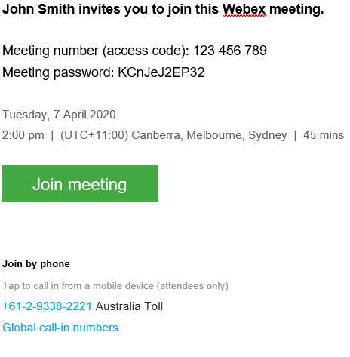
- Participants can click here for further instructions on how to join a Webex Meeting from an Email Invitation.
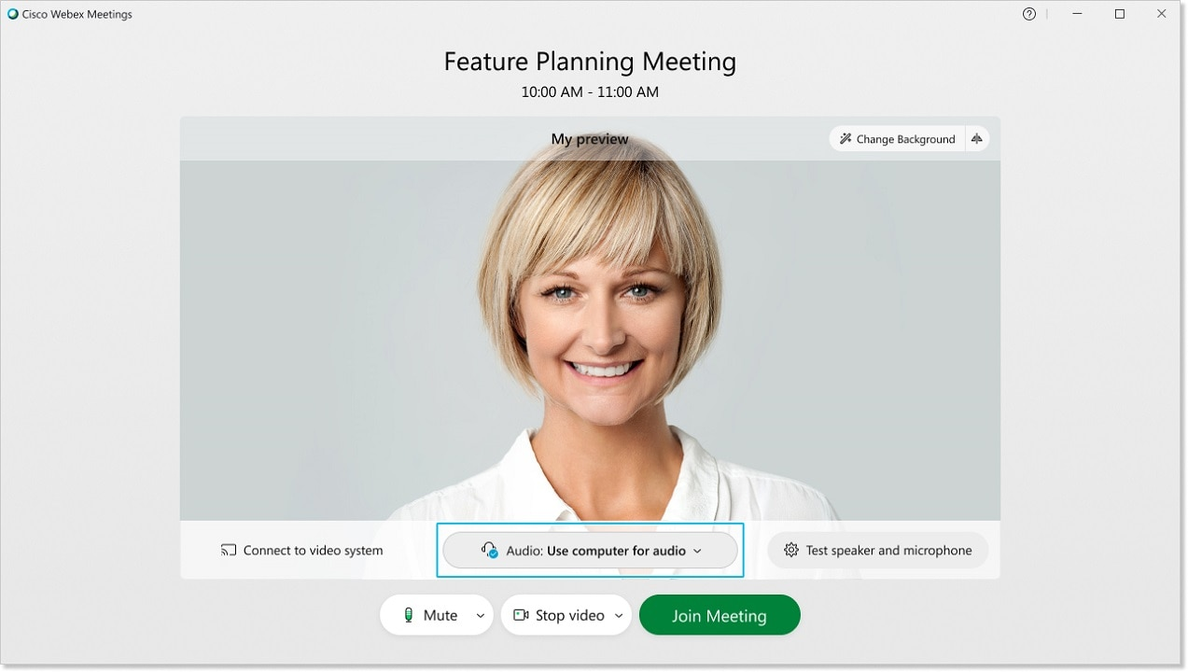
Figure A.
Figure B.

Webex Desktop App
- If this is the first time the participant is using the Webex Meetings desktop app, the participant will be prompted to enter their name and email address and click Next.
- Participants are not required to sign in first but may wish to do so if they have created a Webex account. Alternatively, participants can use the Cisco Webex Meetings desktop app as a guest.
- To join a Webex meeting by way of the desktop app, open the desktop app and enter a Personal Room ID, meeting number, or meeting link in the ‘Join a meeting’ search bar, and click Join to enter the meeting (Figure C).
- The Court may require that participants use a meeting password (which is found in the email invitation). If prompted. enter the password and click ‘Join meeting’.
- Participants can set-up their audio and video settings as required.
- Then click ‘Join meeting’ to attend the Webex hearing.
- Participants can watch a YouTube video on how to join a Webex conference through the desktop app by clicking here.
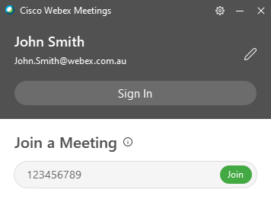
- Alternatively, participants can click here for instructions on how to use the Cisco Webex Meetings Desktop App as a guest.
Figure C.

Mobile Device (smartphone or tablet)
- Participants should open the mobile app and tap . Participants are not required to sign in first but may wish to do so if they have created a Webex account (Figure D).
- Enter the meeting number (in the email invitation), name and email address and tap Join.
- The Court may require that participants use a meeting password (in the email invitation). Enter the meeting password (in the email invitation) and tap Join (Figure E).
- Participants can set up their audio and video settings as required.
- Click Join to attend the Webex hearing.
- Participants can watch a YouTube video on how to join a Webex conference using the mobile app by clicking here.
- Alternatively, participants can click here for instructions on how to connect to Webex Meetings from a mobile device.
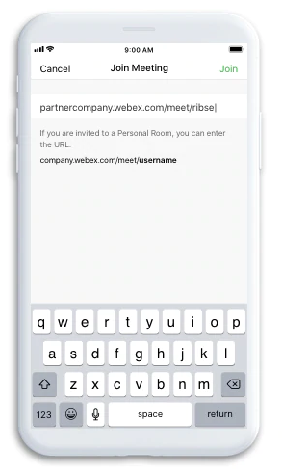

Figure D. Figure E.

Web-Interface
- Click the Join meeting button in your email invitation to join the Webex conference.
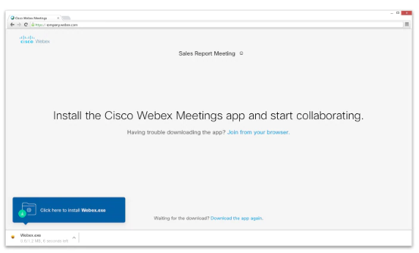
- Click Join from your browser (Figure F).
Figure F.
- The participant is to enter their details and click ‘Next’ (participants are not required to sign in first but may wish to do so if they have a Webex account).
- The Court may require that participants use a meeting password (in the email invitation). Enter the meeting password (which is found in the email invitation) and tap ‘OK’.
- Participants can set up their audio and video settings as required.
- Participants can watch a YouTube video on how to join a Webex conference using the web browser by clicking here.

Telephone Appearance
- Some participants may need to appear or attend at the Webex hearing by telephone.
- This can occur by the participant dialling the Court or the Court dialling the participant.
- If the Court is connecting to the participant by telephone, the participant will receive a telephone call with an automated greeting stating: ‘Welcome to Webex. Press 1 to be connected to your meeting.’ Once the participant presses 1, they will then be connected to the Webex hearing.
- The email invitation contains the details for participants to call into the Webex hearing (Figure G).
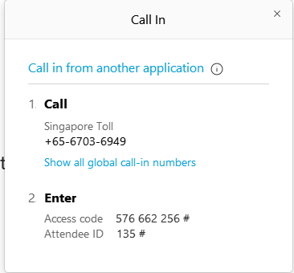
- Participants should dial the telephone number noted in the email invitation.
- Then participants will need to enter the access code (also contained in the email invitation).
- This will allow the participant to join the Webex hearing by audio only.

Figure G.

How to Change Your Virtual Background
  - The Court has made a number of courtroom backgrounds available that may be used by members of the legal profession when participating in County Court virtual hearings and trials.
  - Participants should only use the courtroom backgrounds provided by the Court, or a neutral background that is otherwise appropriate for appearing in court.
  - The courtroom virtual backgrounds can be downloaded from the County Court website under Virtual hearings and trials.

How to Change Your Virtual Background Before You Join a Meeting
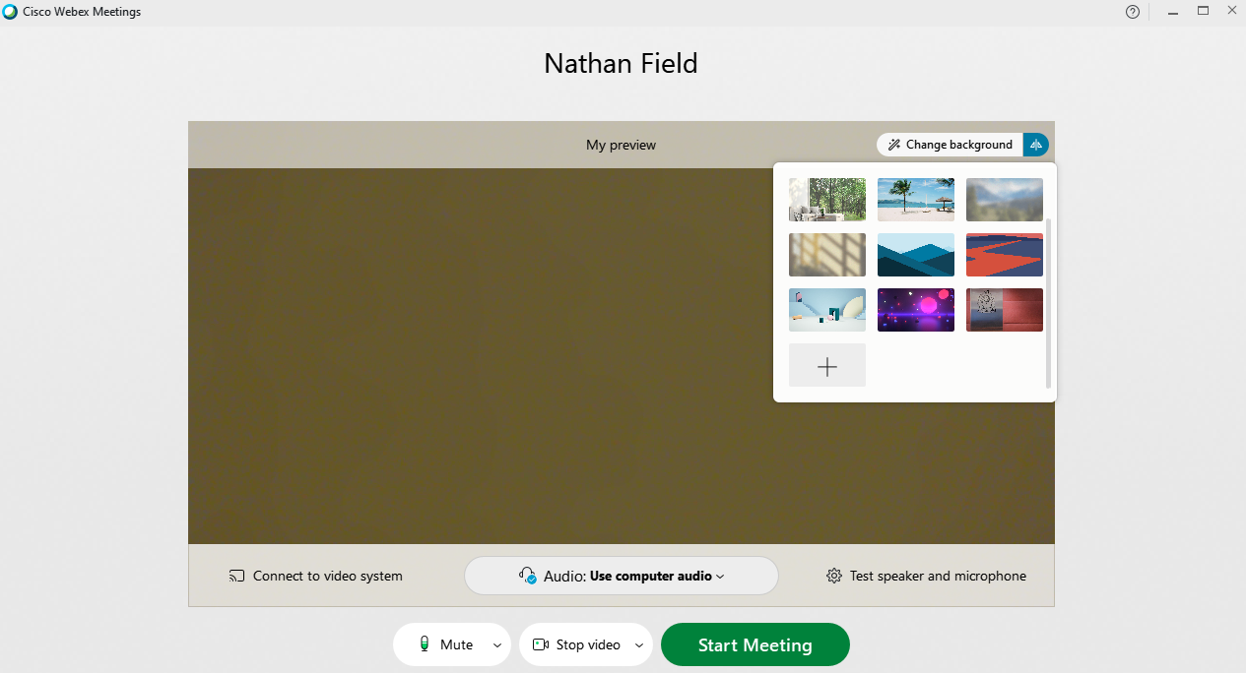
  - To change your background before joining the Webex meeting, select Change Background, then press the + icon to search for the image you would like to set as virtual background.

  - Please note, your web-camera will need to be turned on to change your virtual background.
  - Search for the image you would like to set as your virtual background and press Open.
  - The image you select will be saved to your computer and can be used again for later meetings. However, if would like to use the same image on another device, you will need to add it to your new device.

How to Change Your Virtual Background During a Meeting
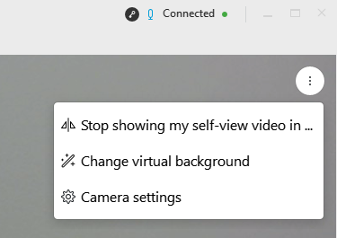
  - To change your background during the Webex meeting, click on the ellipses in your self-view window located towards the top of the screen, and select Change Virtual Background.
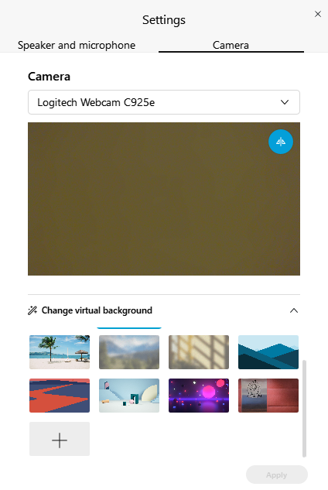
  - Select the + icon to search for the image you would like to set as virtual background.
  - Search for the image you would like to set as your virtual background and press Open.
  - The image you select will be saved to your computer and can be used again for later meetings. However, if would like to use the same image on another device, you will need to add it to your new device.

During the Hearing
  - As noted above, it is anticipated that the Webex invitation will invite participants to join the Webex hearing approximately 10-15 minutes before it is intended that the hearing will commence.
  - During this pre-hearing time, the judge’s associate and/or tipstaff will conduct testing. Testing will be done to ensure the connection between the courtroom, Webex and any video-links is working. In addition, this time will be to ensure that the audio and video of each participant are working and to troubleshoot and resolve any problems before commencing with the hearing.
  - Participants should join from a quiet place, and as much as possible, somewhere that provides a neutral backdrop. This is to avoid unnecessary distraction, noise or identification of the participant’s location.
  - The Court also strongly recommends that participants wear a headset, or headphones with a built-in microphone. This is to avoid background noise and to ensure that there is no sound feedback loop.
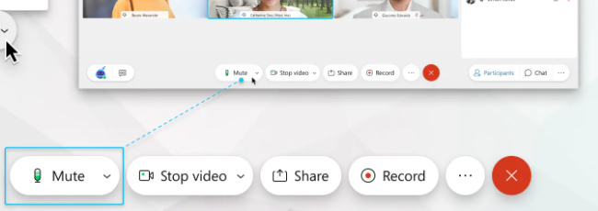
  - Participants should mute their microphones when they are not speaking. To mute or unmute, click on the Mute or Unmute to turn your microphone off or on.

  - Where multiple participants are joining Webex from the same location, only one audio source should be used. This means that only one Webex participant from the same location should have their microphone and computer sound on. In court, this means that all microphones and computer sound will be turned off, as the in-court technology is being utilised instead. This is to avoid creating a feedback loop.
  - If there is a need for counsel to confer with the accused, where they are remote from each other, all other Webex participants can be asked to leave the Webex hearing to allow confidential discussions. At an agreed time, or when directed to by email from the judge’s associate, the participants who have left the meeting can re-join the Webex hearing by following the same steps they initially undertook to join.
  - For convenience, judges may direct participants to follow certain conventions to ensure the hearing proceeds smoothly (for example, raising a hand to speak). This will be a matter for the presiding judge.
  - Unless otherwise directed by the presiding judge, the chat and share content functions will not be utilised in Webex hearings. The Court has taken this position to avoid complicating the remote hearing process and to ensure that all participants can easily participate in the hearing without distraction.

Calling or Tendering Evidence
  - Witnesses may appear at a hearing and give evidence by Webex.
  - Before the hearing, the party calling the witness will have provided the presiding judge’s associate with any witness’ email address and telephone number and an estimate of when the witness will need to join the hearing.
  - During the hearing, at the appropriate time, the associate will send a Webex invitation to the witness to join. The witness will need to accept using one of the above methods. Once the witness does so they will join the Webex hearing along with all other participants.
  - As usual, the witness will be sworn or affirmed by the judge’s staff (either appearing from court or remotely via Webex).
  - During the giving of evidence, both counsels may wish to have their microphones un-muted. This will allow the party calling the witness to question their witness and the other party to object.
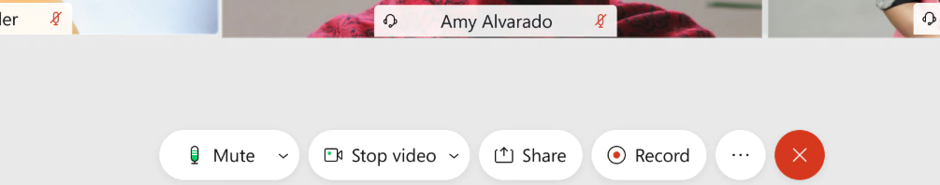
  - Once the witness’ evidence is completed, the judge will excuse the witness. The witness will need to click on the red at the bottom right of their Webex screen. This will create a pop-up window, with an option to ‘Leave Meeting.’ The witness must then select ‘Leave Meeting.’

  - The same process adopted for witnesses can also be adopted for interpreters and intermediaries, if they are going to appear by Webex.
  - Written material/submissions or proposed exhibits should be e-lodged in advance of the hearing. If it is not possible to do so, parties may email the judge’s associate and other parties with any written material and exhibits during the hearing.

Recording and Transcription
  - As noted above, a Webex hearing can be linked to the in-court technology, in addition to video-links, allowing all participants to be joined in the same virtual hearing. This is the case even where a judge is sitting remotely.
  - Where the Webex conference is linked to the in-court technology, the ordinary recording and transcription of the hearing can be continued. That is, the Victorian Government Reporting Service (‘VGRS’) can access, record and transcribe the hearings.
  - A connection to the in-court technology will be the preferred approach adopted by the Court, unless it is not practicable to do so.
  - In the event that a Webex hearing cannot be linked to the in-court technology, then it is possible to record the participants who have joined the Webex hearing, through the Webex application. The host (the Court) has the capacity to record through Webex. Other participants joining cannot record through Webex.
  - If a hearing is recorded through Webex, the recording will be provided to VGRS, for VGRS to continue to archive and transcribe in the ordinary manner.

Formalities and the Law
  - For hearings, judges may continue to preside over matters by sitting on the bench in the courtroom. However, there may be instances where a judge is presiding over a matter from a remote location (chambers or elsewhere).
  - Unless otherwise directed by the judge presiding over the hearing, the usual formalities of a court hearing will continue to be followed. Such formalities that will continue to be followed include opening the Court, announcing the matter and the wearing of robes by the judge and their staff.
  - Participants appearing remotely by Webex are taken to be appearing as though they were present at court. This means that laws that would apply in court, including laws relating to evidence, procedure and contempt of court and perjury, will continue to apply.
  - Participants joining via Webex should also note that this means that it continues to be an offence to record a court hearing without permission of the Court. As noted above, participants do not have the ability to record a hearing through Webex, but participants must not use other means to record the Webex hearing or take photos or screenshots of the Webex conference/hearing.

Questions or Issues
  - County Court eHearings Support Team – For support enquiries for both general and urgent matters related to Webex, please contact the eHearings Support Team on 8636 6472 or via email at CCV-eHearings.Support@courts.vic.gov.au
  - Alternatively, please inform the associate to the presiding judge via email as soon as practicable. The associate will assist you through Webex, or through an alternative method where required.
  - If you are experiencing complex technical issues, you should contact Webex support. Webex support can be accessed by clicking here or via telephone on 1800 129 278.
  - Webex also offer several helpful video tutorials here about how to use Webex Meetings.

https://www.webex.com/downloads.html/
Refer to [3.2] - [3.5].
Throughout this document a reference to Judge may also refer to a judicial registrar.
Section 42E of the Evidence (Miscellaneous Provisions) Act 1958.
Throughout this document a reference to participants also refers to observers.
Section 42G of the Evidence (Miscellaneous Provisions) Act 1958.
Section 3B of the County Court Act 1958.
https://www.countycourt.vic.gov.au/files/documents/2019-09/media-accreditation-policy-2019.pdf.
https://www.webex.com/test-meeting.html.
https://www.webex.com/downloads.html/
https://help.webex.com/en-us/ozygebb/Join-a-Cisco-Webex-Meeting#Join-a-Meeting-from-the-Webex-Meetings-Desktop-App-or-Mobile-App
https://help.webex.com/en-us/nt2ig0y/Choose-Your-Audio-and-Video-Settings-Before-You-Join-a-Webex-Meeting-or-Event
https://www.youtube.com/watch?v=Y-_jey84hEo&list=PL_YnWo4XhzTfhkcwB6M1a-wJ9dTlz58yz&index=19
https://help.webex.com/en-us/x8p8cw/Use-the-Cisco-Webex-Meetings-Desktop-App-as-a-Guest
https://help.webex.com/en-us/nt2ig0y/Choose-Your-Audio-and-Video-Settings-Before-You-Join-a-Webex-Meeting-or-Event
https://www.youtube.com/watch?v=Y-_jey84hEo&list=PL_YnWo4XhzTfhkcwB6M1a-wJ9dTlz58yz&index=19
https://help.webex.com/en-us/x8p8cw/Use-the-Cisco-Webex-Meetings-Desktop-App-as-a-Guest
https://help.webex.com/en-us/nt2ig0y/Choose-Your-Audio-and-Video-Settings-Before-You-Join-a-Webex-Meeting-or-Event
https://www.youtube.com/watch?v=7l_W-iiGi_Q&list=PL_YnWo4XhzTfhkcwB6M1a-wJ9dTlz58yz&index=26
https://www.countycourt.vic.gov.au/going-court/virtual-hearings-and-trials
Refer to the steps outlined in [9.6].
See section 3B of the County Court Act 1958.
Section 42W of the Evidence (Miscellaneous Provisions) Act 1958.
Section 4A of the Court Security Act 1980.
https://help.webex.com/contact
https://help.webex.com/en-us/8bzter/Cisco-Webex-Meetings-Video-Tutorials

