Electronic inspection of subpoenaed material
Instruction manual for Parties and Practitioners
DOCUMENT CONTROL
Details
Document type | Instruction manual
Reviewed by | Subpoena Managers
Authorised by | Subpoena Managers
Notes | This process was developed in response to coronavirus (COVID-19).

Release history
Version | Date | Author | Summary of changes
1 | 23/04/20 | Business Analyst – Digital Transformation | Document created
2 | 01/05/20 | Business Analyst – Digital Transformation | Addition to paragraph 4.2, c)  Addition and amendment to paragraph 5.1

Related documents
Document title | Version
Instruction manual Addressees | 1
Notice to Parties and Practitioners | 2
Notice to Addressees | 1

CONTENTS
1. Purpose 4
2. Scope 4
3. Obligations 4
4. Requesting to inspect 4
5. How to access material 4
6. Objections to inspection 6
7. Questions 6

Purpose
  - In response to COVID-19, the County Court (the Court) is seeking to minimise physical contact in relation to the subpoena management process. The Court has developed a process for the electronic inspection of subpoenaed material by parties and their solicitors, that will apply to most matters and will minimise the need to attend the Court. This document serves as a how-to-guide on how to inspect electronic subpoenaed material.

Scope
  - This process applies to all material that has been produced to the Court in electronic form. If subpoenaed material has been produced in hard copy, this will require an in-person inspection at the Court. Appointments can be made at the time of calling the Subpoena team. Appointments will be scheduled at 09:30am and 11am. At this stage, appointments to inspect hard copy material should only be requested for urgent matters.

Obligations
  - The link provided to you via this process contains subpoenaed material for inspection. You are able to download this material to your local source. Please be aware your obligation concerning use of subpoenaed material continues. This obligation is to keep the material secure and not use it for a collateral or ulterior purpose unconnected to the proceedings in which the subpoena was issued. Examples of collateral or ulterior purposes are using the information in different proceedings; using the material for a business reason; or disclosing the information to people or entities unrelated to the proceeding.
  - All recipients of the material are subject to the undertaking and will only be released from it with leave of the court or through publication of the material in open court.

Requesting to inspect
  - Once an Addressee has produced material in response to a subpoena on a case, parties or their solicitors of that case may request to inspect this material. Material will be available to parties and their solicitors in accordance with the County Court Civil Procedure Rules 2018.
  - If you are seeking to inspect subpoenaed material, please follow these steps:
- Contact the Subpoena team on 03 8636 6525 or at CCVsubpoenas@courts.vic.gov.au. Please ensure you are able to provide the case number, the details of the subpoena to be accessed and a valid credit card for payment (if required).
- If you are required to make payment of the electronic search fee ($14.80) in accordance with the County Court (Fees) Regulations 2018, the Subpoena team can take your payment over the phone, or you can complete a credit card authorisation form.
- The Subpoena team will check if material is available in electronic format and appropriate for electronic inspection. If this is the case, please provide an email address to receive a link to the subpoenaed material. Please note that if this email address does not match the email address currently available on the file, the Subpoena team may request further evidence that this email address belongs to the authorised case party or their solicitor. The Subpoena team will also use this email address to provide a receipt for any payment made in relation to this inspection.

How to access material
  - Once the Subpoena team has confirmed your right to access the material and has gathered all the required documents, a link to the subpoenaed material using Microsoft OneDrive will be sent to you. As the Subpoena team receives many requests for inspection, please be aware that you may not receive this link immediately after phoning the subpoena team. The Subpoena team will send this in order of priority and as soon as practicable. You do not require a Microsoft OneDrive account to access and download this material to a local source. To access the material sent to you via OneDrive, follow these steps:
- Open the mailbox of the email address you have provided to the subpoena team.
- Open the email with the link to the material.
- Note: this link will come from one of the members of the subpoena team. The subject will similar to: “John Smith (CSV) shared the folder “CI-20-00001” with you.”,
- Click on ‘Open’ in the email . Please note that the link will only work for the direct recipient of the email.
- You may be asked to verify your identity by sending a verification code, which will look something like this 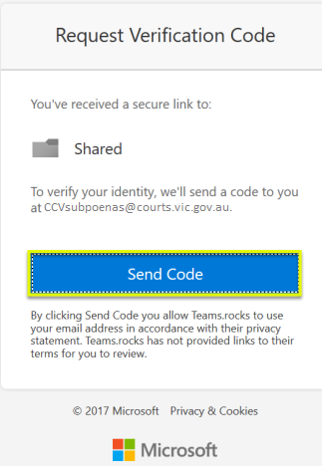.
- Click ‘Send Code’. A secure code will then be sent to your email address.
- Open your mailbox and open the email with the Microsoft OneDrive verification code.
- Enter the verification code from the email and click ‘Verify’. 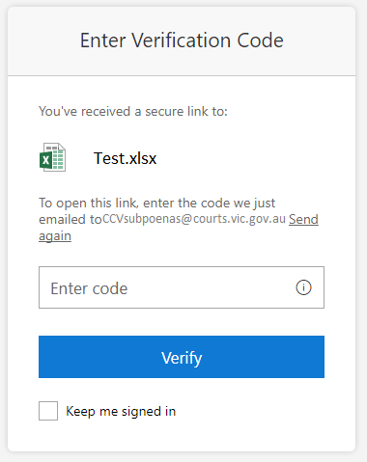
- Once Microsoft has verified your identity, you will be provided with direct access to the material that has been shared with you.
- Download the material to a local source within 24 hours of receiving the link. In order to download all material to a local source at once, follow these steps:
  - select all material by selecting the checkbox next to ‘Name’ so this turns blue .
  - Click ‘Download’ near the top left of your screen .
  - The material will be downloaded as a OneDrive Zip folder looking something like this . By default material will de downloaded to the ‘Downloads’ folder on your computer. However, this may be a different folder depending on your computer settings.
  - The Court suggests moving the downloaded material to a secure folder on your computer or to a USB to ensure material is easily accessible to you.
  - You do not have to notify the Court once you have downloaded the material, as material will only be available for 24 hours.

Objections to inspection
  - Objections to inspection may be lodged via email at CCVsubpoenas@courts.vic.gov.au. Please ensure you clearly identify the material you are objecting to and provide the reasons for your objection.

Questions
  - If you have any issues or concerns, or require further information on the inspection of electronic subpoenaed material, please contact the subpoena team on 03 8636 6525 or via email at CCVsubpoenas@courts.vic.gov.au.

