Common Law Division hearings by Zoom
Information sheet

Overview
  - Zoom is a video conferencing application that you can use on any device, including a computer, tablet or a smartphone. You can access it through the Zoom app on your device, or through an internet browser on your device.
  - Zoom is an excellent tool for conducting online hearings, but technology can require patience. If you have any issues or concerns, please inform the Associate to the Judge or Judicial Registrar conducting the hearing.
  - If at any point during the hearing you find that you are unable to communicate through Zoom, please inform the Associate by email so the Associate can either assist you to communicate through Zoom or through an alternate method.
  - The ability of a participant to interact through Zoom depends on the quality of that user’s internet connection. We encourage all users to access the Zoom video conferencing platform through your device from a site that has reasonable internet speed, whether via WiFi or a cellular network.
  - The Court recommends use of a computer (desktop or laptop) with a large screen. This is because reading documents and seeing other parties is usually easier with a large screen, and a computer enables a participant to manipulate documents more easily than on a device.

Prior to the hearing
  - Provide the email address and mobile phone number of each participant in the hearing by email to the Associate to the Judge or Judicial Registrar conducting the hearing.
  - Download the Zoom application for your device (available free at https://zoom.us/download or in the app store for your device). Zoom is easier to use through the dedicated app than through the web browser. As noted above, it is recommended that you use a desktop or laptop computer, but tablets and smartphones can also be used.
  - Each participant in the hearing (even non-speaking participants such as instructing solicitors who wish to view the hearing) should have their own device with Zoom installed.
  - If possible, familiarise yourself with the Zoom application.

On the day of the hearing
  - You will receive a meeting invitation via your provided email address. The meeting invitation will also have a code that is the meeting ID. We suggest writing this meeting ID down.
  - You can join the Zoom meeting in 2 ways. First, you can click on the link in your calendar appointment, which will open the Zoom application on your device and take you to the meeting. Second, you can open Zoom on the app (Figure 1) or via the website https://zoom.us (Figure 2) and press “Join” and type in the ‘meeting ID’. Click on the link to join the meeting at least 15 minutes prior to the listed start time.

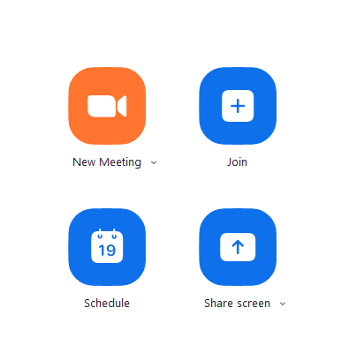  Figure 1 | 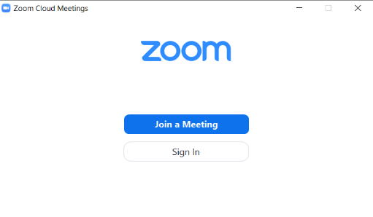  Figure 2 | 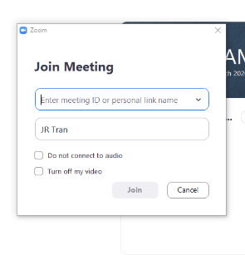  Figure 3

  - You will initially be placed in a virtual waiting room.
  - The Zoom app has a menu bar at the bottom of the screen, set out in Figure 4 below.
Figure 4

  - Please take the opportunity to ensure your microphone, speaker and camera are working and not muted. You can do this by clicking the ^ (or v) icon next to the “Mute” icon on the bottom left hand side of the screen, selecting “Test Speaker & Microphone” and following the prompts (Figure 5).
Figure 5

  - When using a desktop or laptop in Windows, maximise the Zoom window or press “Enter Full Screen” to use the whole of your screen (Figure 6). In a Mac, maximise the Zoom window by pressing the icon on the top right hand corner (Figure 7) or the green dot in the top left of the window (Figure 8).
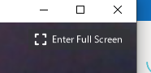  Figure 6 | Figure 7 | Figure 8

  - When the Judge or Judicial Registrar is ready to commence the hearing, the Associate will permit you to join the meeting.

During the hearing
  - You can mute and unmute your own microphone, by pressing the “Mute” or “Unmute” icon on the bottom left hand side of your screen (see Figure 4 above).
  - Unless you are using a small device such as a mobile phone, you can switch between “Speaker View” (view primary speaker – Figure 9) and “Gallery View” (view all participants – Figure 10) by hovering over the top right-hand corner of the video and clicking on the appropriate icon. If you are using a small device, you can view other participants by swiping left or right across the screen.
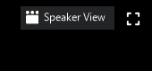  Figure 9 | Figure 10

  - When muted by clicking the “Mute” icon, you can click on the “Participants” icon and then “Raise Hand” to let the Judge or Judicial Registrar know you want to speak (Figure 11).
Figure 11 | or

  - You can send text messages to all participants, or a private message to a single participant (eg: your instructing solicitor). To send a message, first click the “Chat” icon on the bottom of the screen (see Figure 4 and figure 12).
Figure 12

  - A white box will appear after you click the “Chat” icon. To send a private message, click on the “Everyone” icon in the box and select the person you want to message (Figure 13). If left unchanged, your message will go to everyone that is on the conference, including the Judge or Judicial Registrar. We recommend not sending private messages in Zoom, in case a participant accidentally sends a private message to everyone.

Figure 13

  - You can share documents and other files by clicking the “Chat” icon (see Figure 4 and 12 above). In the “Chat” pop-up box, select “Everyone”, or a particular person to message, and then press the “File” icon on the right-hand side and locate the document you wish to send (see Figure 13 above). The document will be sent as soon as you select it. This function works better on a desktop or laptop.
  - If there is a particular document that you would like all participants to view, rather than send it by the “Chat” icon, you can share your screen, which is the green icon on the bottom of your screen. Please orally request permission from the Judge or Judicial Registrar first, then press the “Share Screen” icon (Figure 14). Please note that before you can share documents via this function, you may need to change your computer’s permission settings to allow Zoom to share your documents.
Figure 14

  - There is also a Whiteboard function via the Share screen, which allows the participants to write on a white screen, which is shown to all users. If you want to access the whiteboard for any reason, please orally request permission from the Judge or Judicial Registrar first.

