Frequently Asked Questions
Changes to civil court fee regulations (from 14 December 2018)

When will the new regulations take effect?
The new regulations will take effect on Friday 14 December 2018. The regulations will apply to new and existing proceedings.

Where can I find the new regulations?
You can view the new fee regulations at http://www.legislation.vic.gov.au/Domino/Web_Notes/LDMS/PubStatbook.nsf/b05145073fa2a882ca256da4001bc4e7/43E71636AAFE0F97CA25832F0017A3C0/$FILE/18-172sr.DOCX

How do I know which fee category I am eligible for?
Corporate Fee Payer is a corporation with a turnover of $200,000 or more in the previous financial year. This also includes public sector applicants.
Standard Fee Payer is a natural person not acting in the capacity of a statutory office holder, individuals, sole traders, unincorporated partnerships and corporations with a turnover of less than $200,000. Executors or administrators of deceased estates and not for profit organisations that operate solely for charitable, civil or other social purposes and which do not share funds or profits with owners, shareholders or executives of the organisation are also classed as standard fee payers.
Concession Fee Payer is a person who holds a current health care card within the meaning of the Social Security Act 1991 of the Commonwealth at the time a fee is payable.

Will I have to prove my fee category eligibility every time I file a document with a filing fee and what evidence do I need to provide?
If you are a corporation attempting to pay a standard fee or if you are an individual wishing to pay a concession fee you will need to provide evidence of eligibility for that category. This evidence will need to be provided each time you pay a fee. The evidence will be by way of a completed ‘Statement of Standard/Concession Fee Payer’ which is attached (Attachment 1). Concession fee payers will be required to additionally provide a copy of the relevant health care card.
A completed ‘Statement of Standard/Concession Fee Payer’ and health care card (if relevant) are to be provided for every over the counter lodgement or lodgement via post.
If you are filing documents via CITEC you will be required to confirm the solicitor’s statement for each document where your corporate client is attempting to pay the standard fee or your individual client is attempting to pay the concession fee.

What concession cards will make me eligible for the concession fee rate?
The Court will accept copies of valid Commonwealth issued health care cards – these will carry the Australian government emblem and the words “health care”. Below are some images of acceptable Commonwealth issued health care cards. Please note that Pensioners’ cards are NOT acceptable.

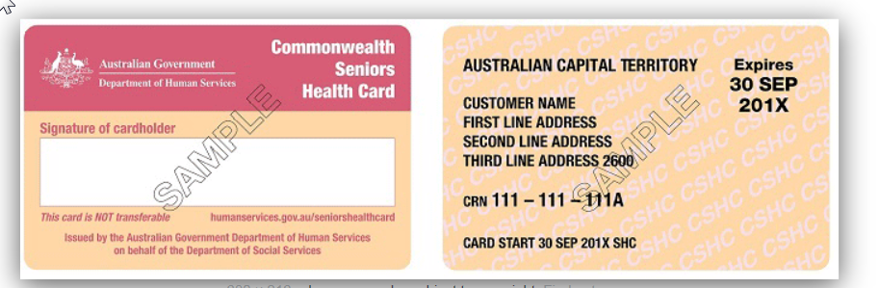

If I am filing on behalf of multiple parties, which fee category applies?
If one or more of the parties is a corporate fee payer, the corporate fee applies.
If none of the parties is a corporate fee payer, but one or more of the parties is a standard fee payer, then the standard fee applies.
If all of the parties are concession fee payers then the concession fee applies.

Is there a different fee for commencing a case in the Commercial Expedited List?
Yes. Parties who request to enter the Commercial Expedited List will need to pay the corresponding fee amount. Cases transferred into the Commercial Expedited List will be required to pay the Commercial Division Expedited List transfer fee.

When are fees payable?
Commencement fees, Case Management fees and Other Application fees are payable upon lodgement of documents or on request of service.
Setting down for trial fee is payable six (6) weeks before the listed date of the first trial day or circuit commencement date.
First trial day hearing fee is payable five (5) days before the listed trial day or circuit commencement date.
Second and subsequent trial days and Other Hearing Day fees are payable by close of business on the day prior to the hearing.
Mediation fees are payable 5 days prior to the date fixed for mediation, or if at the time the mediation is fixed there is less than 5 days until the mediation date, the fee is payable the day after the date for mediation is fixed.

What is the ‘Other Hearing’ fee?
The ‘Other Hearing’ fee is payable for second or subsequent day (other than a trial day) of a:
- Interlocutory Application by summons
- Appeal from a review of determination of a Judicial Registrar
- Filing a summons under Chapter 1 for attachment of debt (Garnishee)
- Filing a summons for oral examination under Rule 61.04 of Chapter I
- Order for oral examination under Rule 67.02 of Chapter I
- Filing for an attachment of earnings order under Order 72 of Chapter I
- For each sitting of a judicial officer or court official taking accounts or evidence
- Application for assessment of damages or value

What is the ‘mediation fee’?
The County Court has three types of 'judicial led mediation', these are:
- Judicial Mediation
- Judicial Settlement Conferences
- Judicial Resolution Conferences
The mediation fee is payable for each of these conferences.

If the setting down fee has been paid prior to 14 December for a trial listed after that date, is the first day hearing fee required to be paid?
No. The setting down fee prior to the introduction of the new regulations encompasses the first day hearing fee.
If you pay the setting down fee on or after 14 December, you will be required to pay the first day hearing fee five days prior to trial date or circuit commencement date.

Is there a fee payable for default judgments and warrants?
There is no longer a fee payable for default judgments.
From 14 December 2018, fees are payable for the issuing of warrants.

How will the Search for Files with copy be charged?
The fee payable is per file search. There are different fees payable depending upon whether the file is electronic or paper. Files from 2017 onwards can be provided in electronic format upon payment of the electronic file search fee. If you require paper copies of documents, photocopying fees will apply. Files prior to 2017 are in paper format and the paper file search fee and any photocopying charges apply.

Am I eligible for a fee waiver?
Fee waiver eligibility is impacted by the new regulations in that there is a new automatic waiver applicable to the following categories of fee payers:
A party, person or other entity who -
- is legally represented in a proceeding under specified pro bono schemes;
- has been granted legal aid under a legal aid scheme;
- is serving a sentence of imprisonment; or
- is under 18 years of age.

An application for a waiver based upon the grounds of financial hardship continues to apply. If you have any queries you should contact the relevant (Melbourne or circuit court) registry.

ATTACHMENT 1
STATEMENT OF STANDARD / CONCESSION FEE PAYER
County Court (Fees) Regulations 2018
In the County Court of Victoria
Proceeding Number: CI-
Case Description:  (Name of Parties) | -v-
Applicant:
(party making this application)
Legal Representative:
(if applicable)
Email: |  | Telephone:

- I am a solicitor who is making this statement on behalf of my client.
- I am a party to this proceeding who is making this statement on my own behalf.

At the time of making this statement, I confirm that:
STANDARD FEE PAYER

- The applicant is an entity that had a turnover of less than $200,000 in the financial year before the current financial year.
- The applicant is an entity which is a not-for-profit organisation that operates exclusively for charitable, civil or other social purposes and does not share or allocate the funds or profits of the organisation with the owners, shareholders or executives of the organisation.
- The applicant is an executor or administrator of a deceased estate.
CONCESSION FEE PAYER

- The applicant is the holder of a current health care card within the meaning of the Social Security Act 1991.
Note - a copy of this health care card must be attached to this form.

In signing this form I acknowledge that:
- This statement is true and correct to the best of my knowledge.
- The applicant may be required to supply additional documentary evidence to support this claim.
- I undertake to provide true and correct information to the Court in relation to my/my client’s financial circumstances in relation to the payment of Court fees during the lifetime of this proceeding.

Signed: _____________________________ Dated: ____________________________

Print Name: _____________________________

Chapter I means the County Court Civil Procedure Rules 2008

