Cl-15-00123
IN THE COUNTY COURT OF VICTORIA AT MELBOURNE

IN THE MATTER of the Confiscation Act 1997 (Vic) and
IN THE MATTER of property which a member of the police force suspects on reasonable grounds to be tainted in relation to a Schedule 2 offence
and

IN THE MATTER of an application by the DIRECTOR OF PUBLIC PROSECUTIONS for Victoria

BETWEEN

PETER ADAMS

and

DIRECTOR OF PUBLIC PROSECUTIONS

ORDER

Applicant

Respondent

JUDGE: DATE MADE:
ORIGINATING PROCESS:

HOW OBTAINED: ATTENDANCE:
His Honour Judge Misso 17 March 2017
Application pursuant to s 36K of the Confiscation Act 1997 (Vic) for exclusion against restraining order by Peter ADAMS dated 3 March 2015

Hearing of 8 March 2017 Mr W Li for the Applicant
Mr P Ridge for the Respondent

THE COURT ORDERS PURSUANT TO SECTION 36U OF THE PROCEEDS OF CONFISCATION ACT1997 (VIC) THAT:
- The application pursuant to s 36U of the Confiscation Act 1997 (Vic) for exclusion against restraining order by Peter ADAMS dated 3 March 2015 be dismissed.
- The applicant pay the costs of the respondent to be assessed by
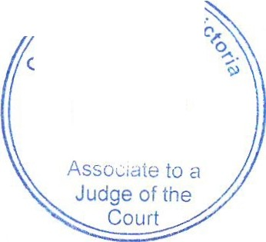
the court in default of agreement.
,
,:>
(Jo
00
'o
-
<;,)
1 7 MAR 2017
court Of

Dated: 17 March 2017

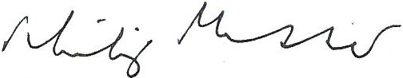
2

JUDGE OF THE COUNTY COURT OF VICTORIA

